Graduate Admissions User Guide

Archivum, University of South Florida



1875 Explorer Street, 4th Floor | Reston, VA 20190

T 703.442.8844 | F 703.442.8919

[www.appian.com](http://www.appian.com)

Contents

**1.** **Introduction** 4

**2.** **Signing into Appian** 4

2.1. Signing On 5

**3.** **Tempo View** 6

**4.** **Managing Program Preferences** 7

*4.1.* *Accessing the “Manage Program Preferences” via Actions* 7

*4.2.* *Manage Program Preferences: Searching/ Editing a Program* 8

*4.3.* *Manage Program Preferences Interface: Selecting Preferences and Requirements* 8

4.3.1. Faculty Scoring Types 9

*4.3.1.1.* *Linkert Scoring Type* 9

*4.3.1.2.* *Percentage Scoring Type* 9

*4.3.1.3.* *Admit/Deny Scoring Type* 10

**5.** **The Graduate Admissions Coordinator Dashboard** 10

Graduate Admissions Coordinator Admissions Decisions 12

Graduate Admissions Coordinator Reports 13

*Admissions by Program* 13

*Duration Report* 13

*Unmapped Applications* 14

Graduate Admissions Coordinator Related Actions 14

**6.** **The Faculty Reviewers Dashboard** 16

**7.** **The Program Director Dashboard** 17

**8.** **Graduate Applications Record** 18

8.1. Navigating the Graduate Applications Record 18

**9.** **Navigating the Graduate Applications Record: The Selected Applicant** 19

9.1. Milestone Bar 20

9.2. The Applicant Checklist 21

9.2.1. Displaying Documents 21

9.2.2. Prior Colleges 22

9.2.3. Test Scores 22

9.3. Applicant Information 22

9.4. Reviews 23

9.5. History 23

9.6. Related Actions 23

9.6.1. Add Note 24

9.6.2. Faculty Review 24

9.6.3. Update Application 25

9.6.4. Exposing Review Results 26

9.6.5. Director Recommendation 27

9.6.6. Updating the Applicant’s Term 28

9.6.6.1. Requesting a change in the Applicant’s Term 29

9.6.6.2. Approving changes for the Applicant’s Term 29

9.6.7. Updating the Applicant’s Program 31

9.6.7.1. Requesting a change in the Applicant’s Program 32

9.6.7.2. Approving changes for the Applicant’s Program 32

# **Introduction**

The Graduate Admissions User Guide will be provided as a resource on navigating the Graduate Admissions application in the Archivum system. This guide will provide a whole hearted overview of the different features and will inform the user on:

* Understanding the Graduate Admissions process in Appian
* Signing into Appian
* Getting an Overview of the Appian Structure
* Navigating Dashboards
* Managing Program Preferences
* Managing Program Group Members
* Adding Notes
* Entering Applicant Reviews
* Updating the Application Checklist
* Exposing Reviews
* Changing an Applicant’s Term or Program
* Entering Final Decision on an Applicant
* Updating a Decision

# **Signing into Appian**

Each user will be able to access the Appian Graduate Admissions Application using the [USF Archivum link](https://usftest.appiancloud.com/suite/portal/login.jsp), where they will be able to sign in using a valid U# and its corresponding password. The main users of Graduate Admissions are as follows:

* The Graduate Admissions Coordinator
* Program Directors
* College Designee
* Faculty Reviewers

Each member of the outlined groups will have access and special privileges to specific sections, actions and related actions found in the Graduate Applications records and actions, wherein they will be able to seamlessly proceed in the Graduate Admissions process.

## Signing On

Upon first signing on to Archivum the user will be directed to the USF NetID Single SignOn, wherein the user will enter their NetID and respective password.

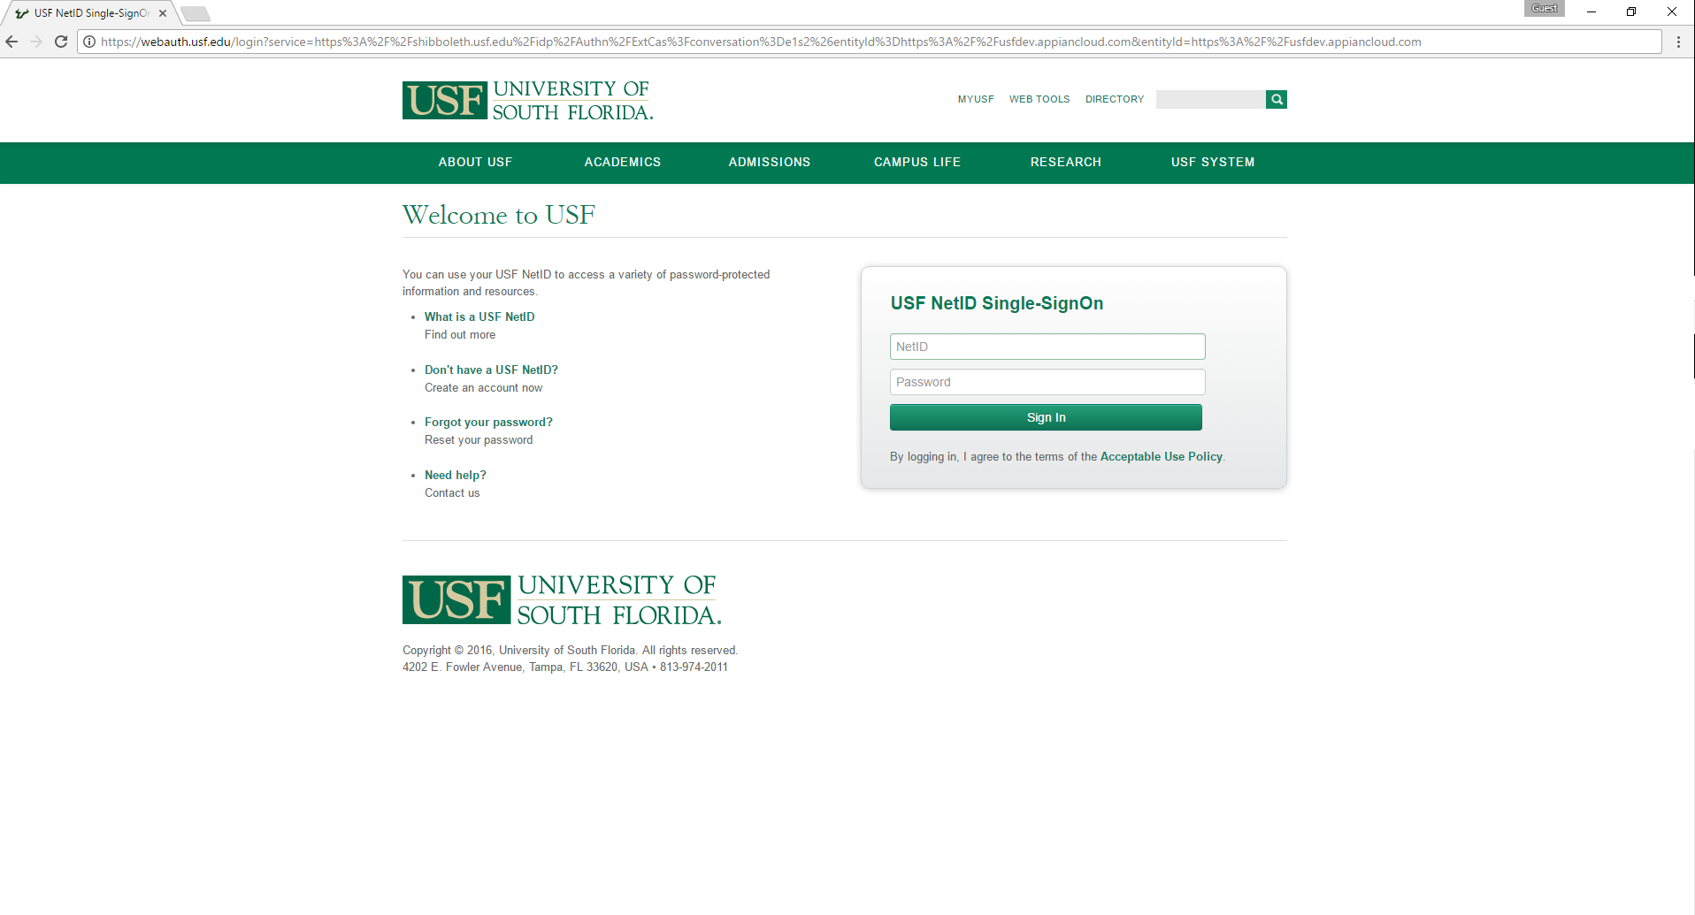

Figure 3. Displaying the USF NetID Single-SignOn webpage.



Figure 4. Appian Sign-in Interface

# **Tempo View**

The users will also have access to the following options:

* ***News*** – This feature provides an update of user activities within the Graduate Admissions process
* ***Tasks*** – Allows for access to work that the user needs to complete.
* ***Reports*** – Contains a collection of data pulled in from different areas of the Graduate Admissions application.
* ***Action*** –Allows the user to start a process.

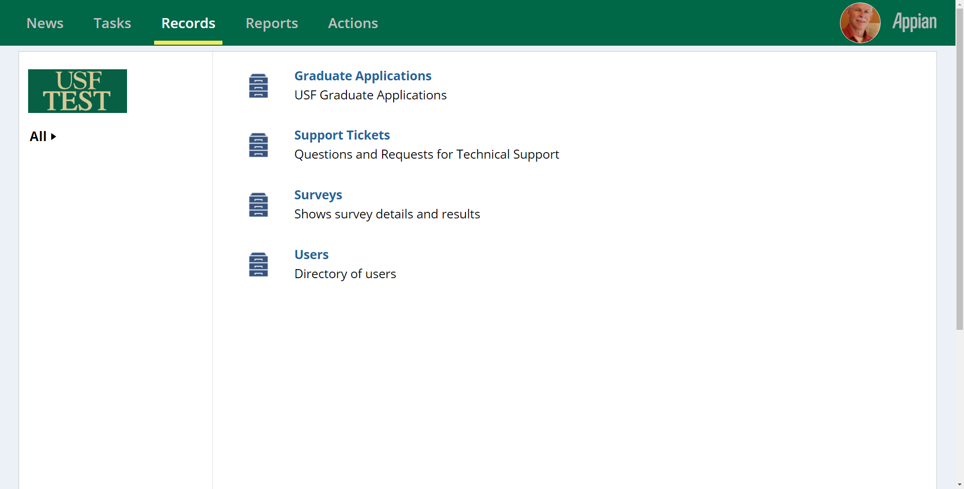

Figure 5. Displaying the list of Tempo items

# **Managing Program Preferences**

Preferences for a program are managed and available only to the Department Designee and is accessible via the “Actions” tab in Tempo. Once the “Manage Program Preferences” options is selected the Department Designee is then able to *(see Figure 7):*

* View the different Majors and Degrees and the associated Program Director and Reviewers.
* Edit the Reviewers
* Search by Major, Degree type, Reviewer or Director

## *Accessing the “Manage Program Preferences” via Actions*

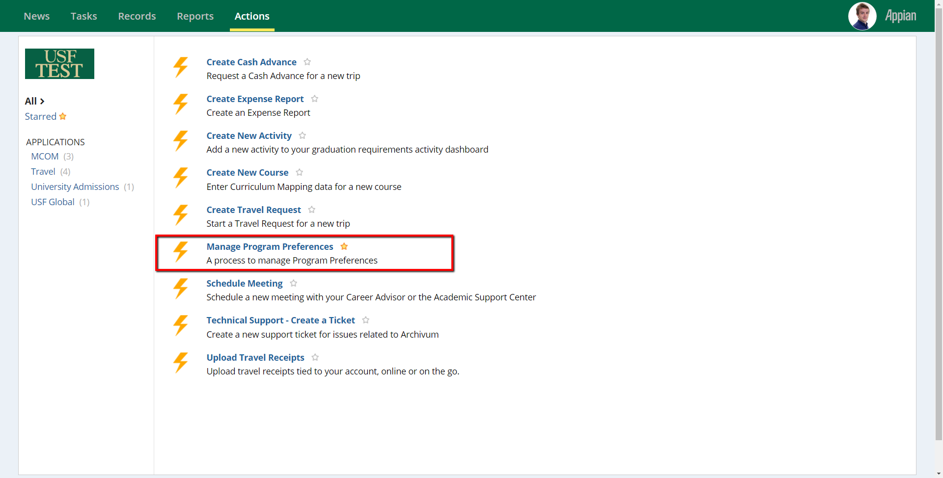

Figure 6. Accessing the Manage Program Preferences via the Actions tab.

## *Manage Program Preferences: Searching/ Editing a Program*

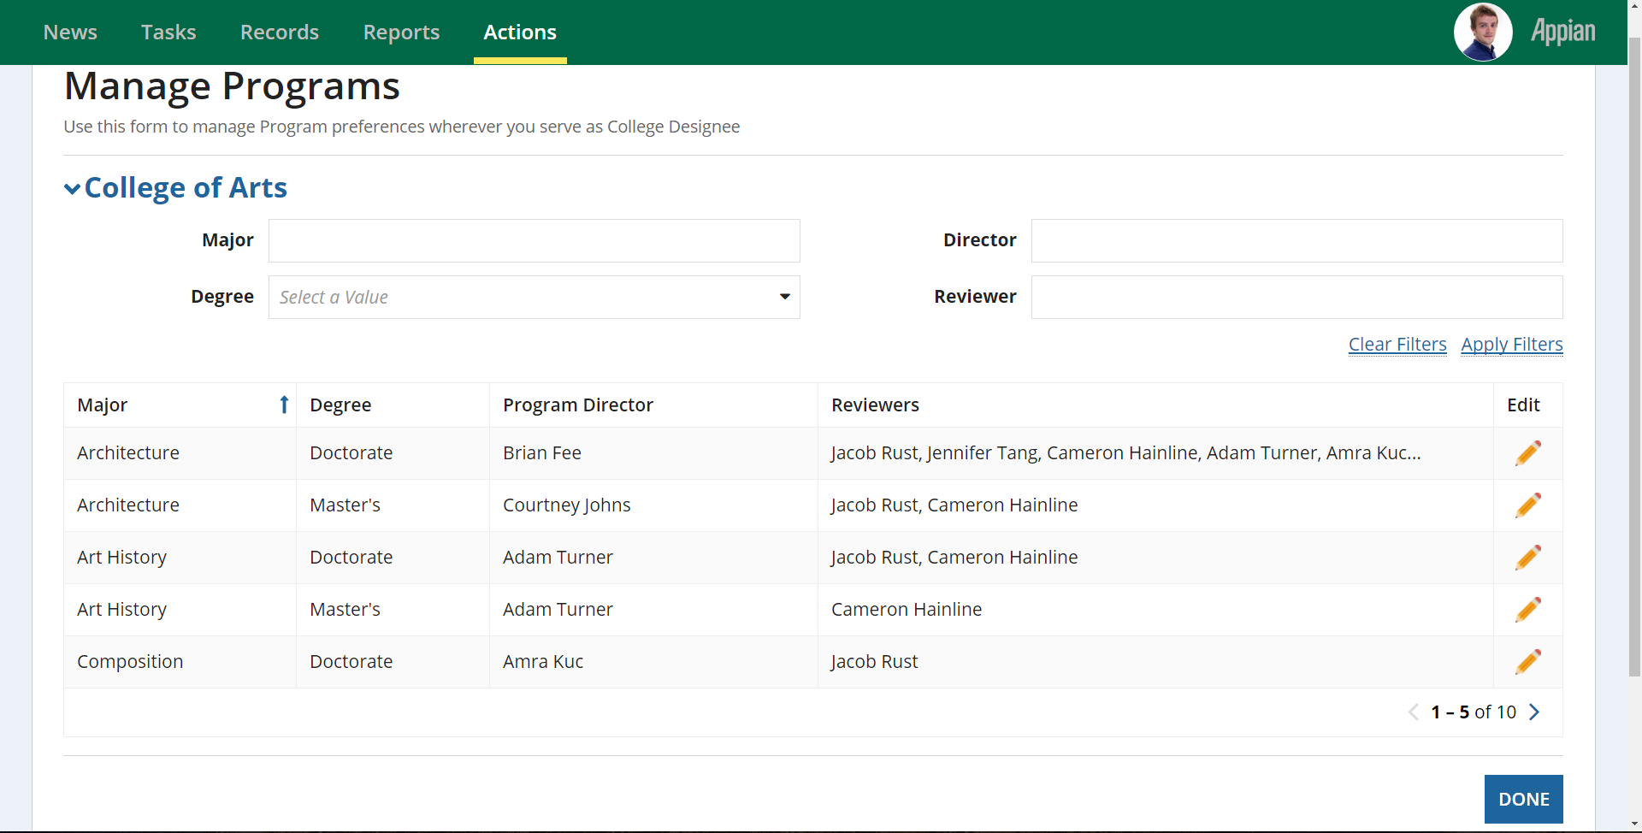

*Search for a Program by Major, Degree, Director or Reviewer*

*Edit/Update a Program by Major, Degree, Director or Reviewer*

*Figure 7. The Manage Program interface displayed once the Manage Program Preferences action is selected.*

## *Manage Program Preferences Interface: Selecting Preferences and Requirements*

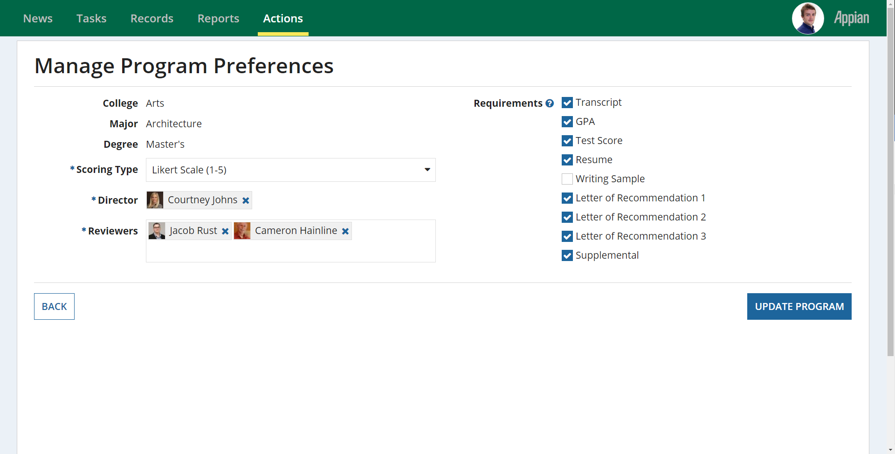

Figure 8. Interface for updating a Program

## Faculty Scoring Types

There are 3 main faculty Scoring Types, namely:

* The Linkert Scale
* Percentage Scale
* Admit/Deny

## *Linkert Scoring Type*

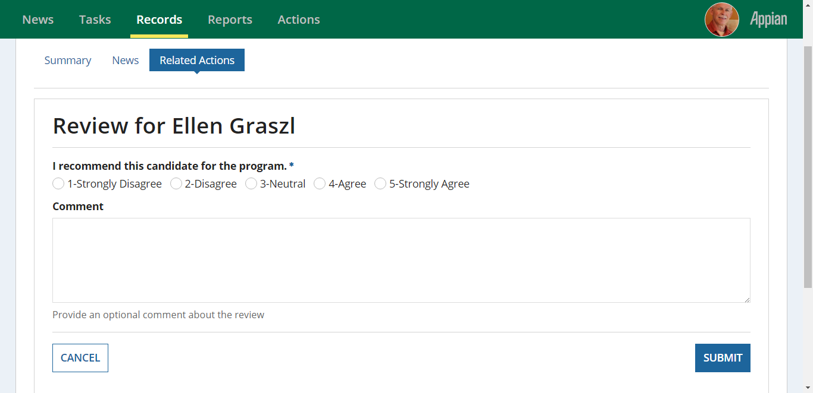

## *Percentage Scoring Type*

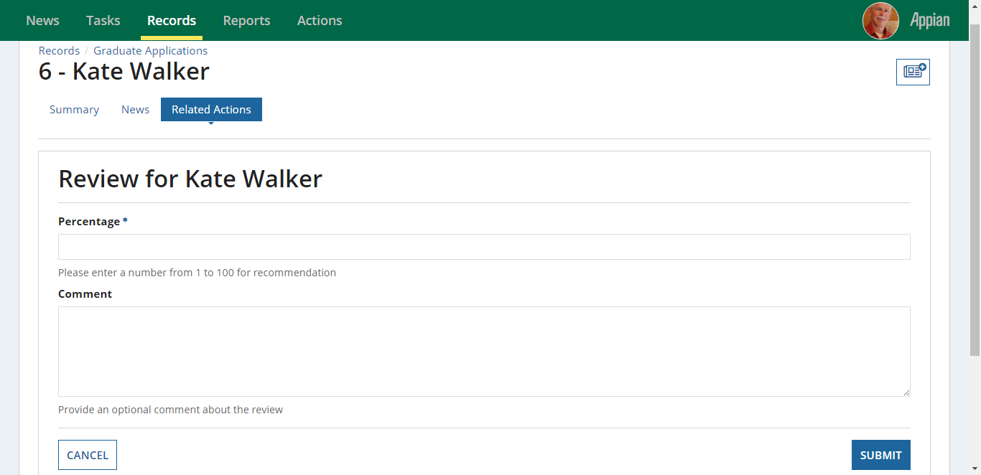

## *Admit/Deny Scoring Type*

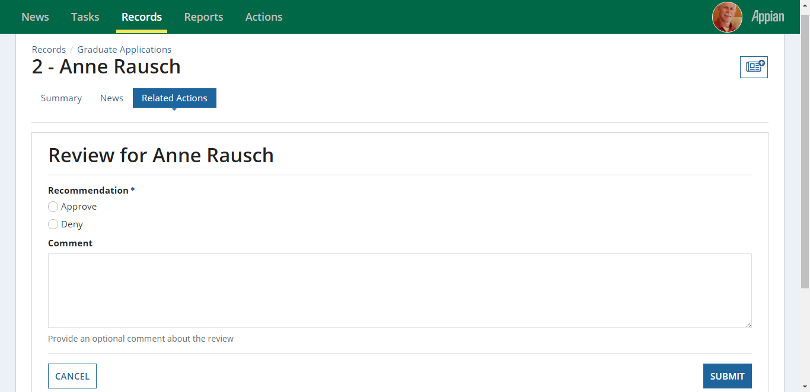

# **The Graduate Admissions Coordinator Dashboard**

Graduate Admissions Coordinators can access their Dashboard via Reports in Tempo.

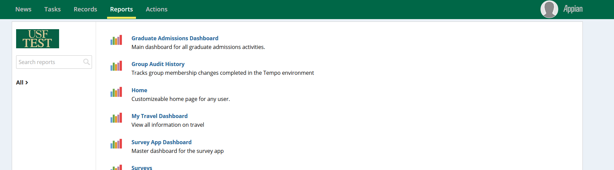

Once on the dashboard the Graduate Admissions Coordinator is able to perform the following actions:

* Search for an applicant by first name or last name
* Filter by the “Decisioned” Status
* Search for an applicant by UNumber
* Quickly view the status of Transcripts, English proficiency and any Holds for each applicant.
* Filter by Stage
* Cancel/Deny a single or multiple applications

|  |  |  |
| --- | --- | --- |
| ***Filter Type*** | ***Options*** | ***Icon*** |
| *Status* | * Graduate Admissions Initial Review * Director Review * Graduate Admissions Final Decision * Admitted * Denied * Waitlisted * Withdrawn * Canceled | *Not applicable* |
| *Decisioned?* | Decisioned | ✓ |
| Not Decisioned | ✕ |

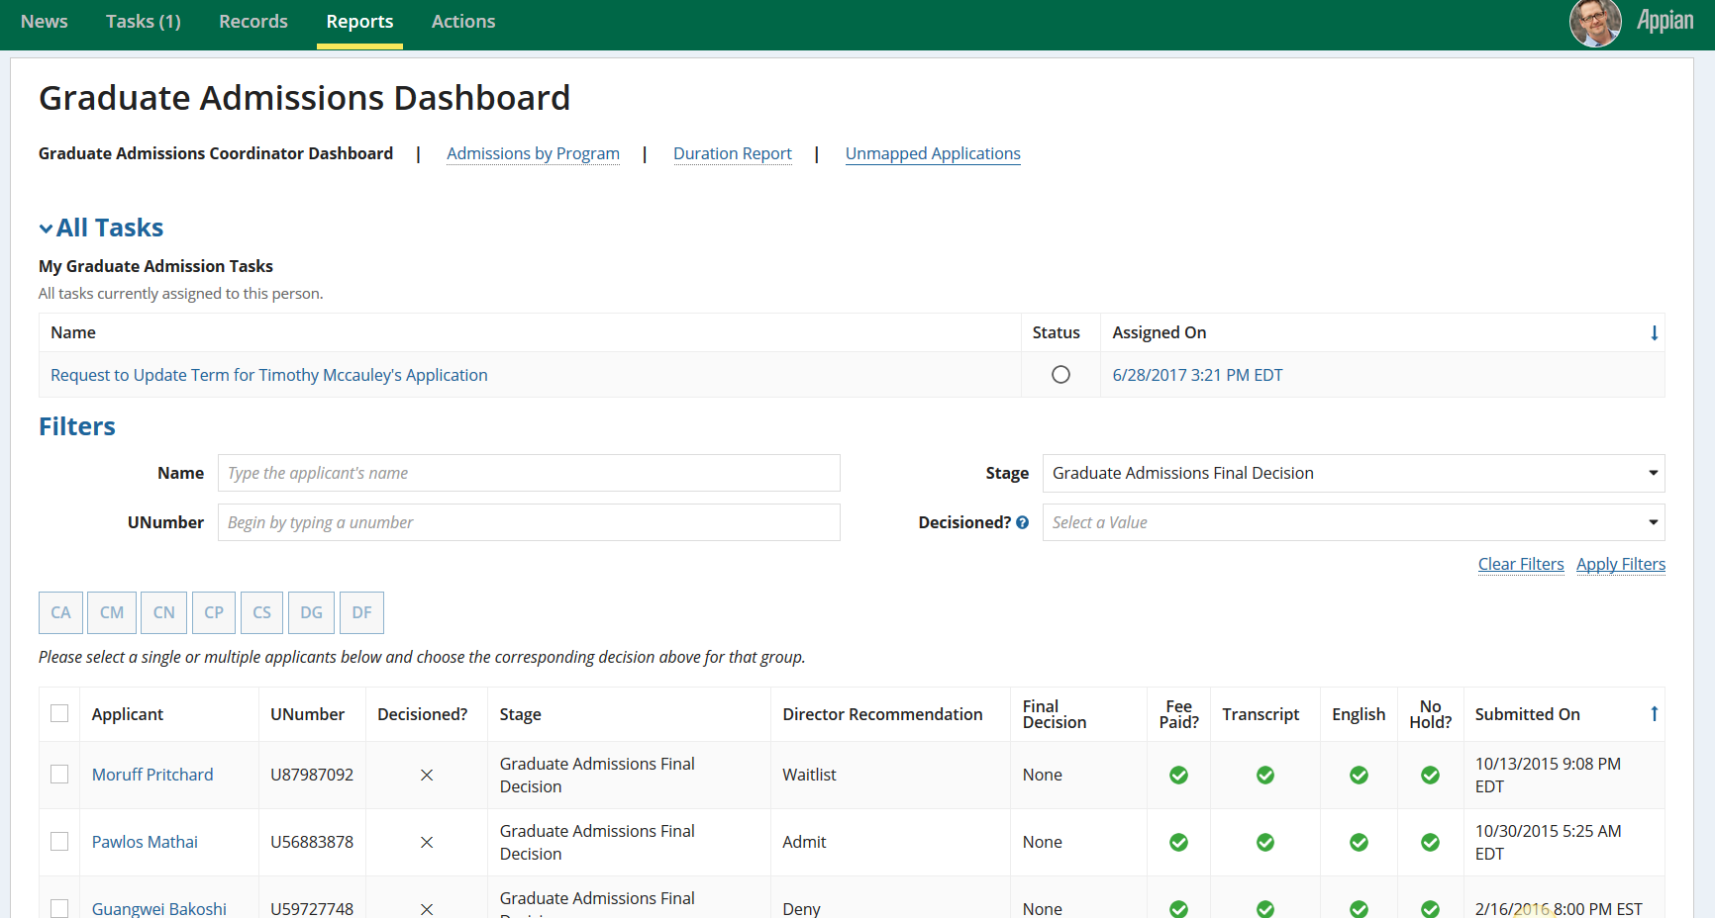

*Filter used for isolating applicants that you have not provided a decision on*

Figure 9. Graduate Admissions Coordinator Dashboard view for the Graduate Admissions Coordinator.

## Graduate Admissions Coordinator Admissions Decisions

From their dashboard, Graduate Admissions Coordinators can make a final decision on a single or multiple applications by selecting the desired applications and clicking on the appropriate decision code button. These decisions are automatically updated in Banner, and reflected in Archivum after the next nightly sync.

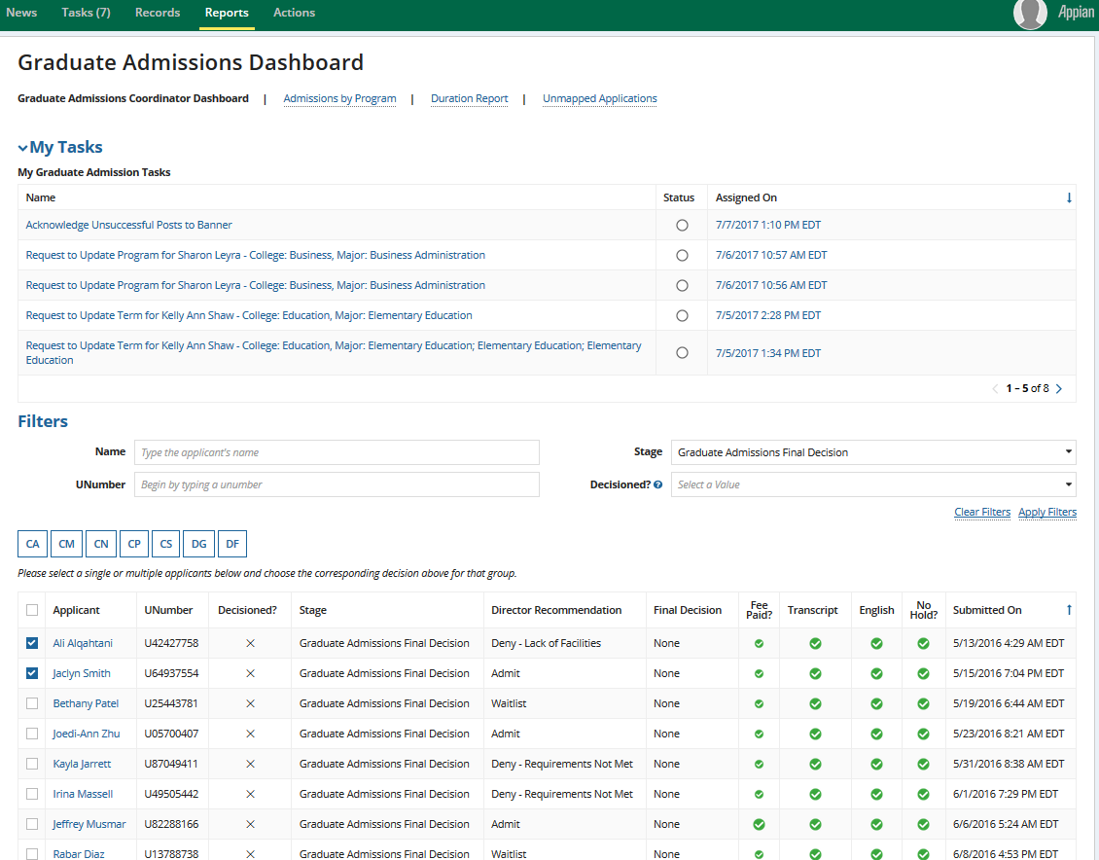

*CA, CM, CN, CP, CS are decision codes associated with cancelling applications. DG and DG are decision codes associated with denying applications*

Occasionally, decision updates to Banner are unsuccessful. In such cases, the system will generate a task for the GAC who initiated the process. This task will ask them to acknowledge the details of the applications for which the update was unsuccessful, and rather make these changes manually in Banner. The task will appear in both the GAC’s Tasks tab and their task report on the Graduate Admissions Coordinator dashboard.

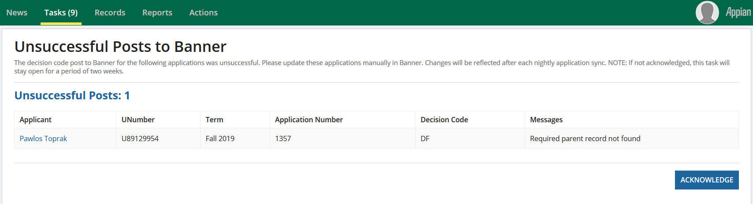

*Update the application manually in banner before you hit the Acknowledge button.*

## Graduate Admissions Coordinator Reports

The Graduate Admission Reports in the Graduate Admissions Dashboard provide concise visual representation of specific aspects of the Graduate Admissions process. This includes insight to the following areas:

* ***Admission by Program –*** *Displays the number of students admitted to a program and the number of applications in the pipeline for that program.*
* ***Duration Report –*** *Displays overall time that applications spend in a specific stage of the Graduate Admissions process.*
* ***Unmapped Applications -*** *Displays the codes for applications that do not map to any program at USF*

### *Admissions by Program*

The Admissions by Program report indicates the number of applicants that have been admitted, denied and waitlisted by a program. The grid also shows Pipeline, which displays the number of applications that are currently in Initial Review for each program, and Percent Decisioned, which displays the ratio of decisioned applications over pipeline.

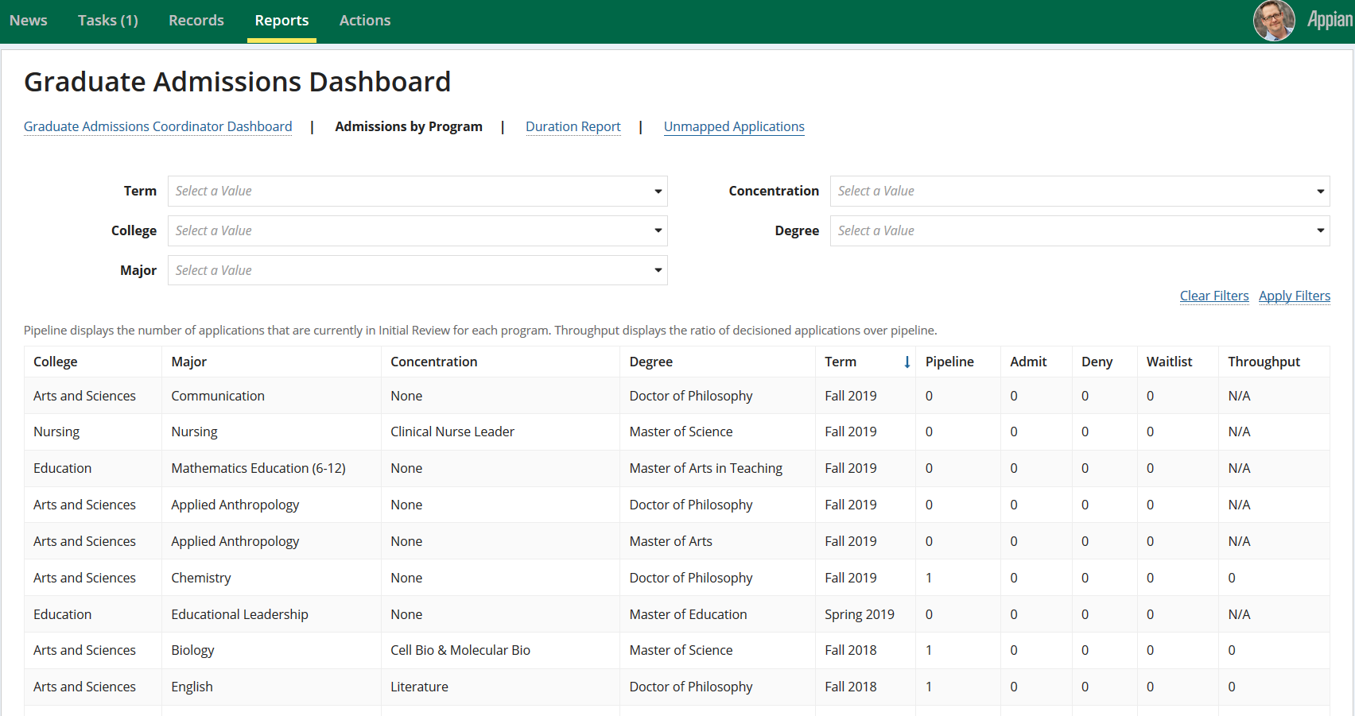

Figure 10.Displaying the Admissions by Program report in the Graduate Admissions Coordinator Dashboard.

### *Duration Report*

The Duration Report indicates the time that an application stays in specific stages of the Graduate Admissions process. Those stages are Initial Review, Director Review, Final Review and the total time that an application stays in the admissions process. 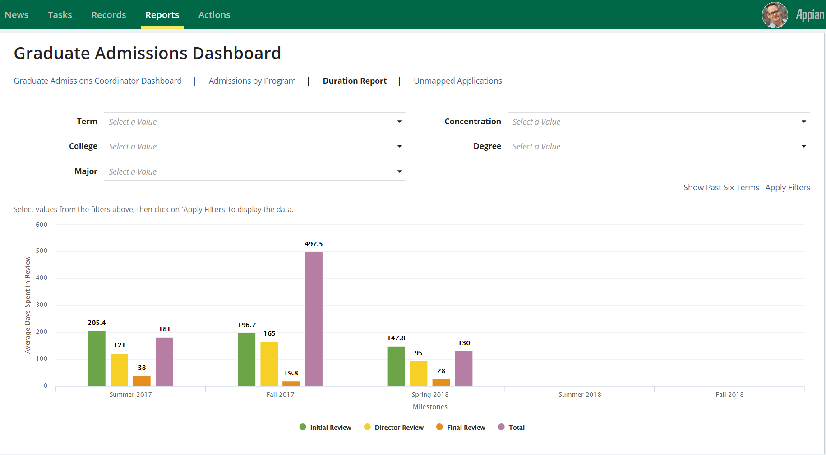

Figure 11. Displaying the Admissions by Program Report in the Graduate Admissions Coordinator Dashboard.

### *Unmapped Applications*

Displays the codes for applications that do not map to any program at USF. To resolve this issue, update their codes in Banner. Changes will be reflected after each daily application sync.

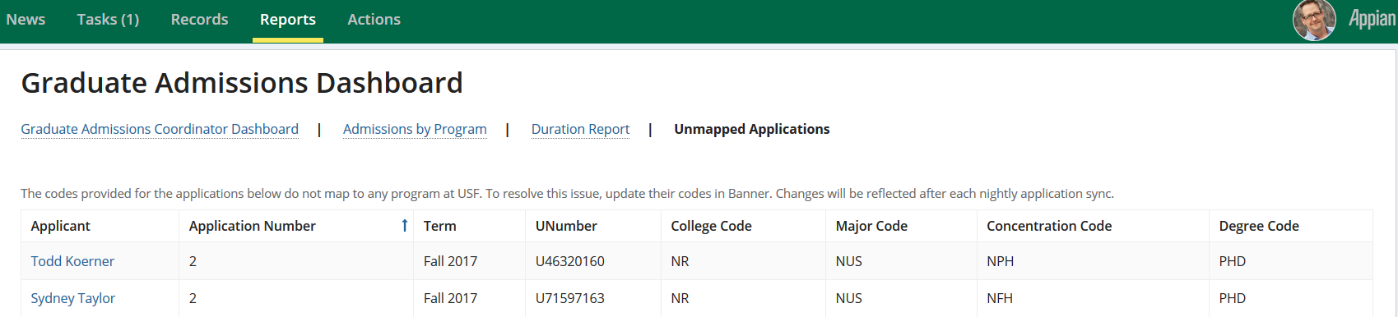

Figure 12. Displaying the Unmapped Applications in the Graduate Admissions Coordinator Dashboard.

## Graduate Admissions Coordinator Related Actions

As a Graduate Admissions Coordinator, the user can add notes, validate application checklists and send email notifications to applicants about their missing documents. The Related Actions are accessible from the Summary page of an application.



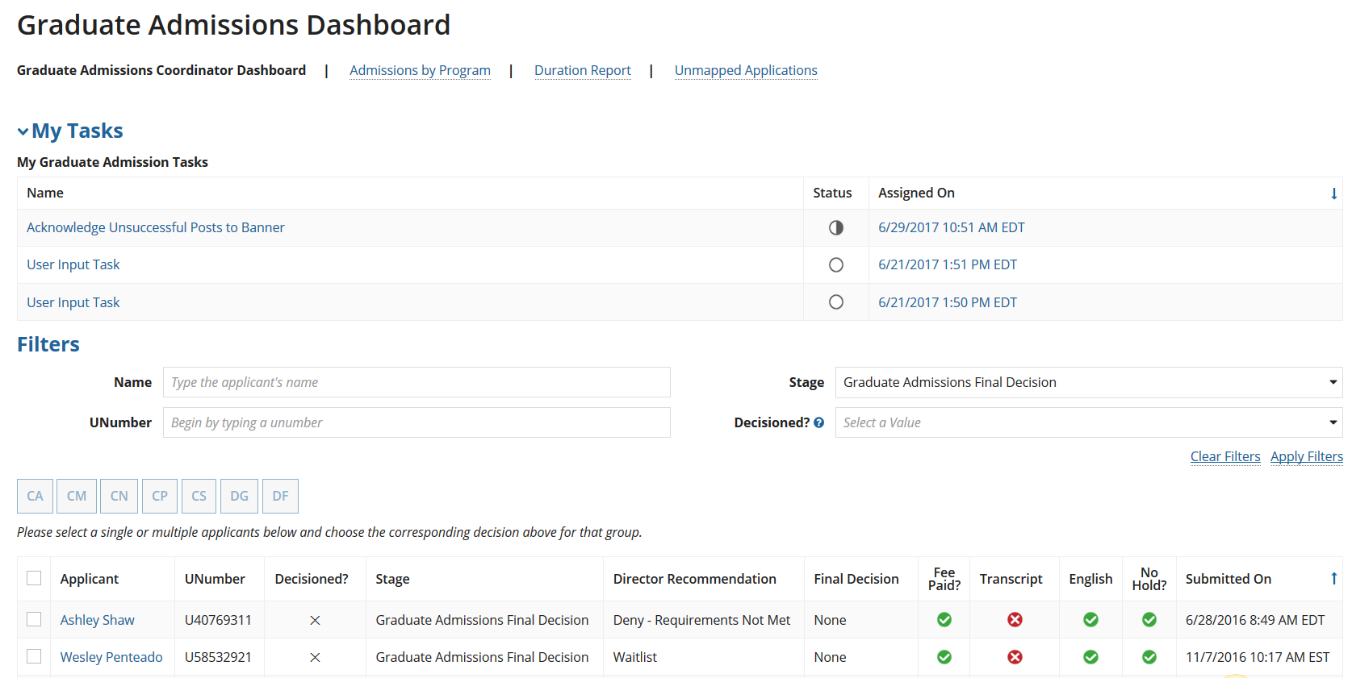

*Choose an applicant to add notes, update application or email about the missing documents.*

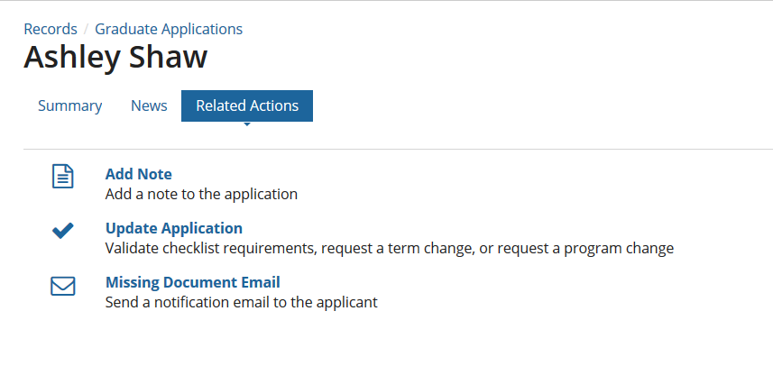

# **The Faculty Reviewers Dashboard**

The faculty reviewer’s dashboard is accessed via Reports in Tempo. Once on the page the Faculty Reviewer is able to perform the following actions:

* Search for an applicant by Name
* Filter by the “Reviewed” Status
* Filter the Graduate Admissions pool by Status

|  |  |  |
| --- | --- | --- |
| ***Filter Type*** | ***Options*** | ***Icon*** |
| *Status* | * Admissions Initial Review * Director Review * Graduate Admissions Final Decision * Admitted * Denied * Waitlisted * Withdrawn * Canceled | *Not applicable* |
| *Reviewed?* | Reviewed | ✓ |
| Needs Review |  |
| Reviews Closed | ✕ |

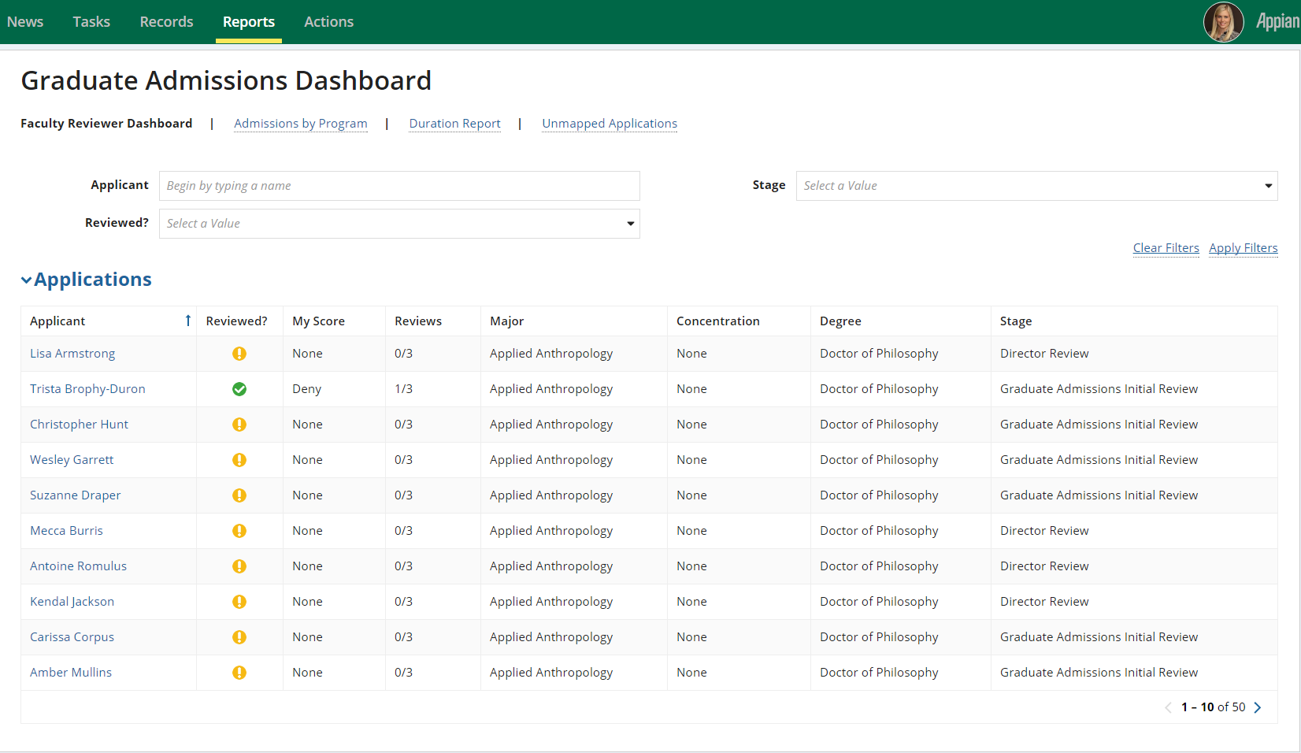

Figure 13. University Admissions dashboard view for the Faculty Reviewers

# **The Program Director Dashboard**

The Program Director dashboard is accessed via Reports in Tempo by clicking on the Graduate Admissions Dashboard report. Once on the page the Director is able to perform the following actions:

* Search for an applicant by Name
* Search for an applicant by UNumber
* Filter an applicant by USF GPA
* Filter the Graduate Admissions pool by Stage
* Quickly view the status of Transcripts, Test Scores, Resume and other additional information for each applicant.

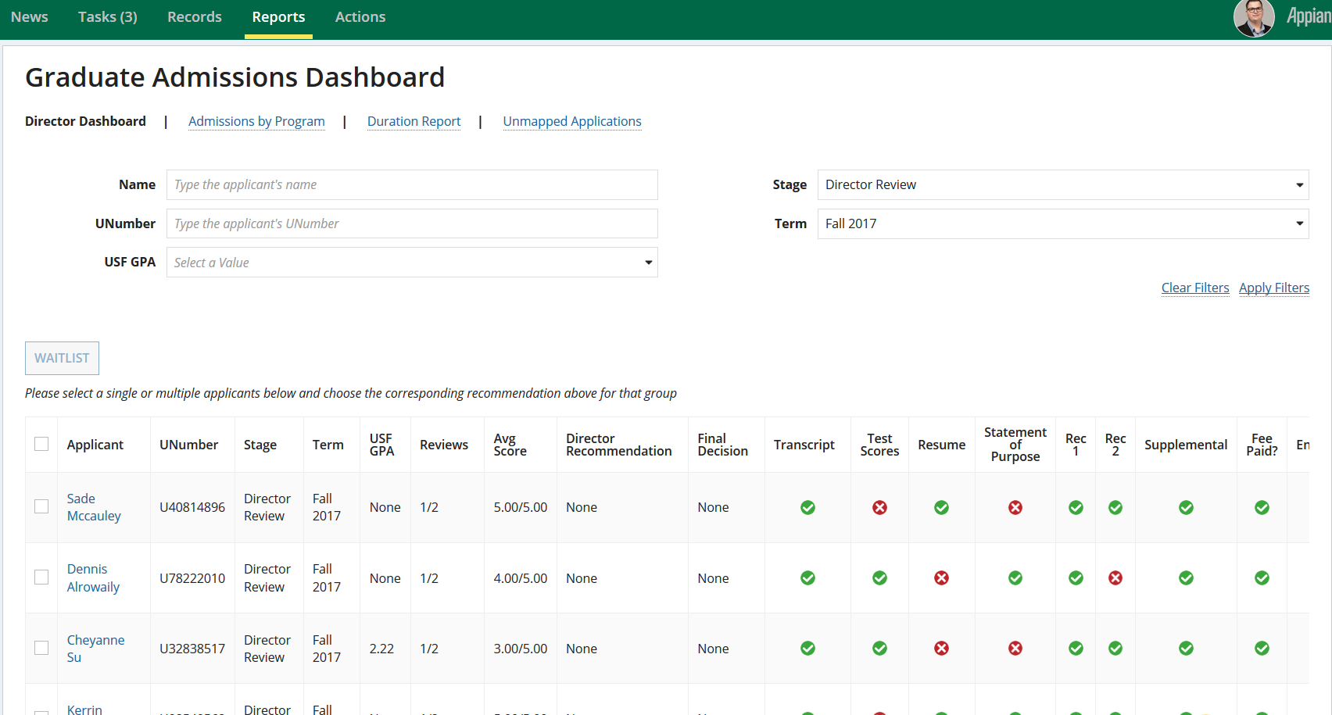

*Ability to Waitlist applicants in bulk.*

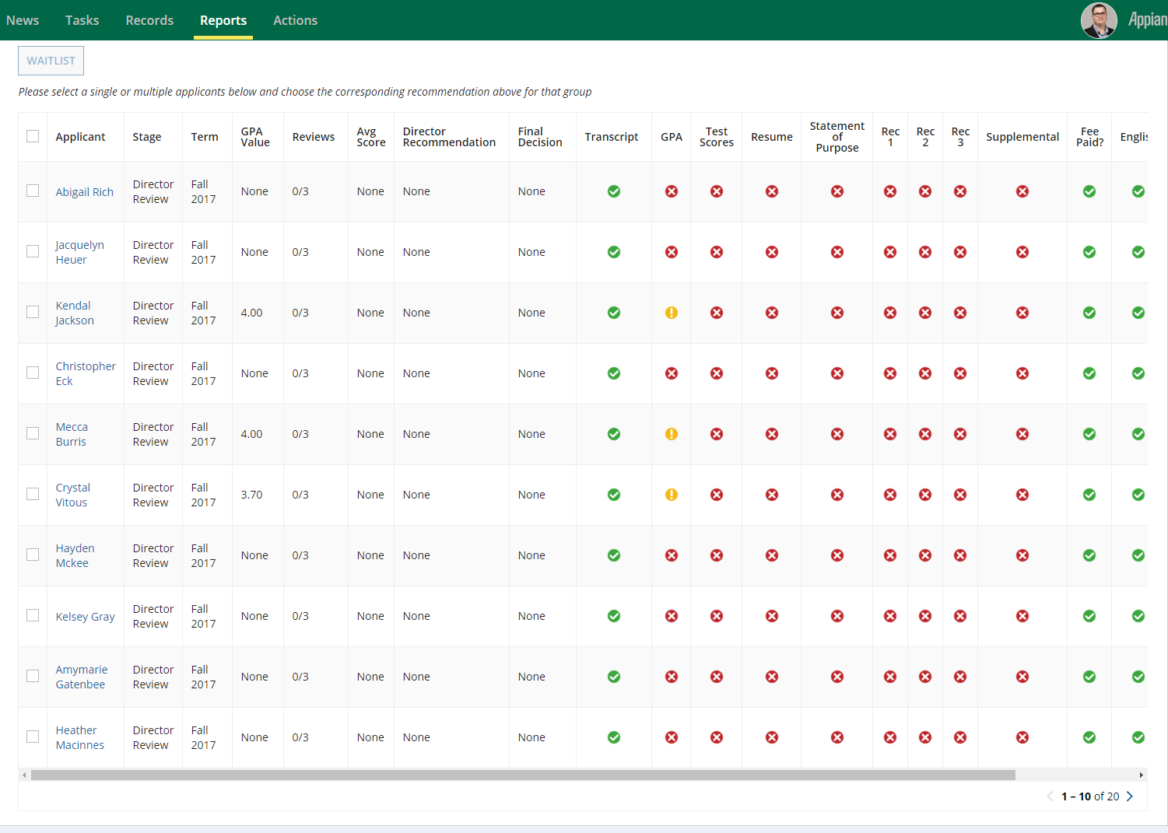

*Slide the grey bar to see additional information on an applicant.*

Figure 14. University Admissions dashboard view for the Program Director.

# **Graduate Applications Record**

The Records tab is comparable to a large filing cabinet of all information regarding applications submitted for Graduate Admissions review and processing. All applicants associated to the Graduate Admissions process are located in the “Graduate Applications” Record. 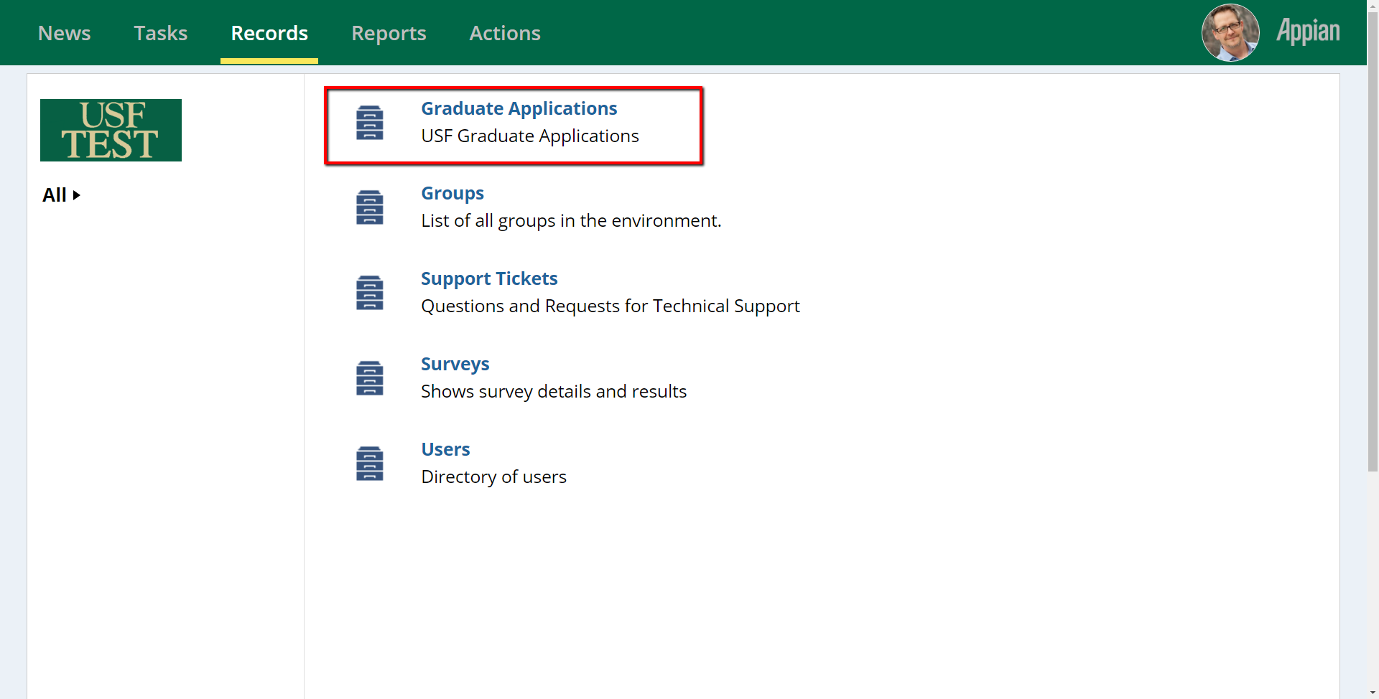

Figure 15. Displaying the Graduate Application Record

## Navigating the Graduate Applications Record

Upon selecting the Graduate Applications Record from the Records tab, the Graduate Admissions Coordinator, Faculty Reviewer, Program Director or Department Designee will be able to:

* Access all the applicants in the Graduate Applications Record
* Select an applicant
* Search for a candidate by Name

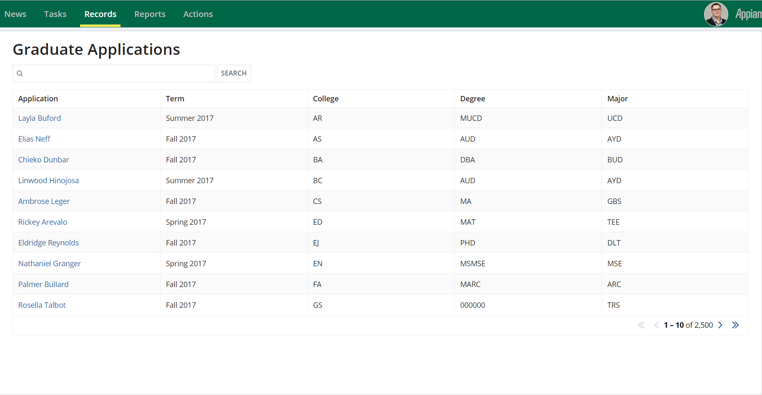

Figure 16. Displaying the applicants in the Graduate Applications record.

# **Navigating the Graduate Applications Record: The Selected Applicant**

Once an applicant is selected, the user will be able to view information related to the applicant. This includes:

1. *Milestone Bar – Shows the progression of the application in the Graduate Admissions process*
2. *The Applicant Checklist – Provides a visual representation of the documents required for a specific major, as well as its status.*
3. Prior Institutions*-Displays an applicant’s prior institutions’ information.*
4. Documents*-Displays all the documents for an applicant.*
5. Official Test Scores*-Displays an applicant’s official test scores.*
6. *Applicant Information – Displays an applicant’s biographical information**.*
7. *Reviews – Displays the review rating submitted by a Faculty Reviewer for a specific applicant**.*
8. *History – Contains a history of the actions taken on a specific application*
9. *Related Actions* 
   * 1. Add Note
     2. Faculty Review
     3. Update Application
     4. Missing Document Email
     5. Expose Reviews
     6. Director Recommendation

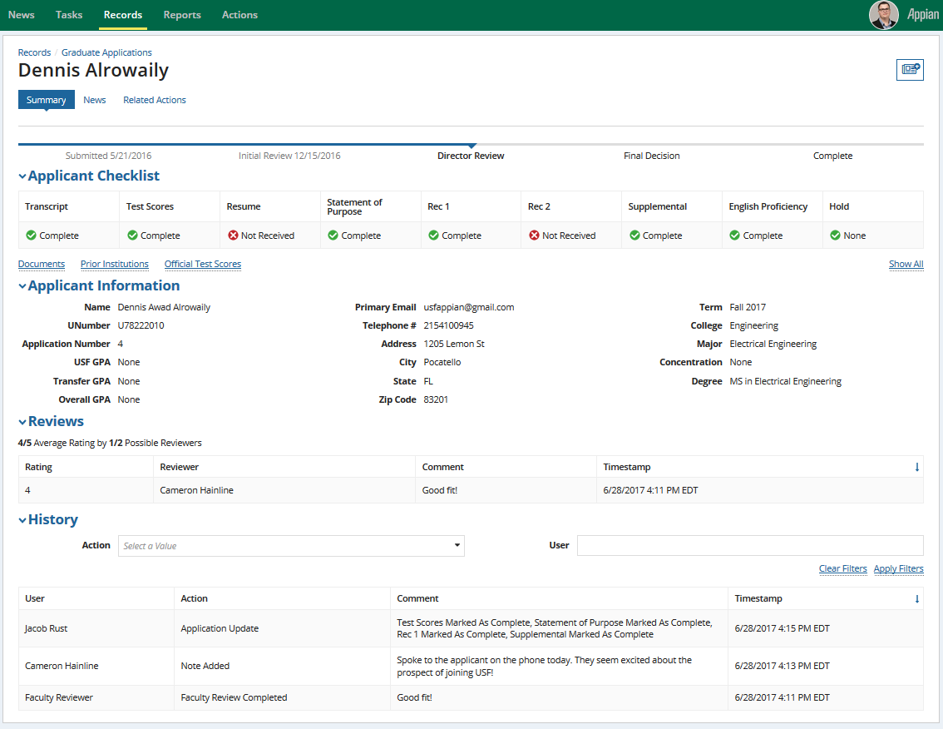

Figure 17. Displaying the interface of the Applicant's record

## Milestone Bar

The “Milestone Bar” indicates the status of an application in the Graduate Admissions process. The application can be positioned in one of five milestones:

* Submitted
* Graduate Admissions Initial Review
* Program Review
* Graduate Admissions
* Completed

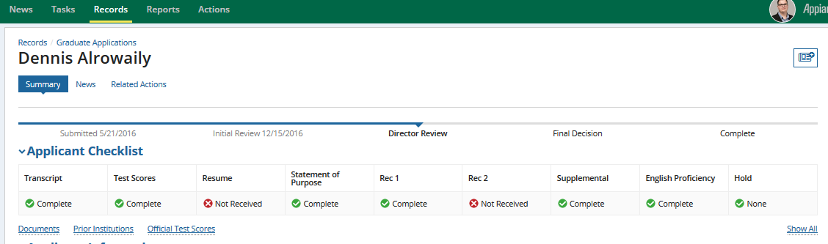

*Milestone bar*

Figure 18. Displaying the Milestone bar in the applicant record.

## The Applicant Checklist

The “Applicant Checklist” is considered a quick glance of the overall status of an applicant’s documentation, and outlines whether documentation has been provided or verified. Columns in the checklist are dynamic and display the checklist items denoted by the Department Designee depending on the specific programs.

|  |  |  |
| --- | --- | --- |
| ***Filter Type*** | ***Comment*** | ***Icon*** |
| *Not received* | Document has not been received |  |
| *Complete* | Document has been reviewed and verified |  |
| *Reviewed* | Document has been received but not reviewed |  |

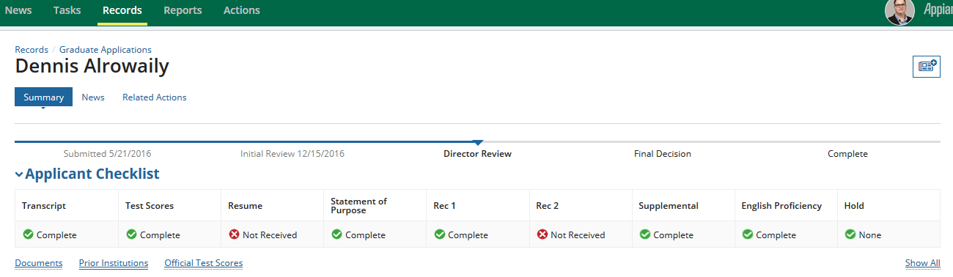

*Select the Show All text to show all checklist options*

*Select the hyperlink text to view additional information checklist options*

Figure 19. Display of the applicant checklist and milestone.

### Displaying Documents

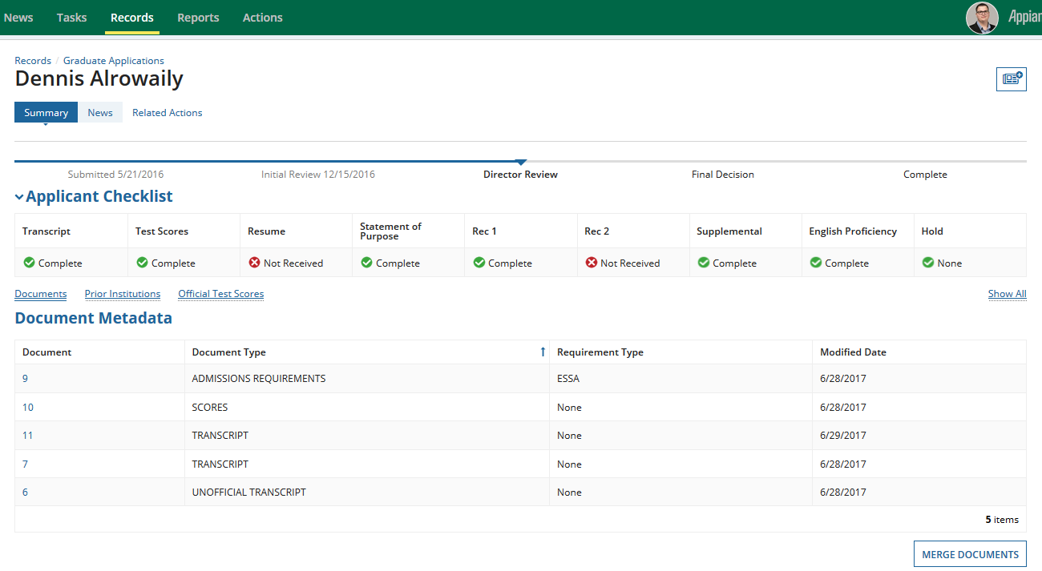

### Prior Colleges

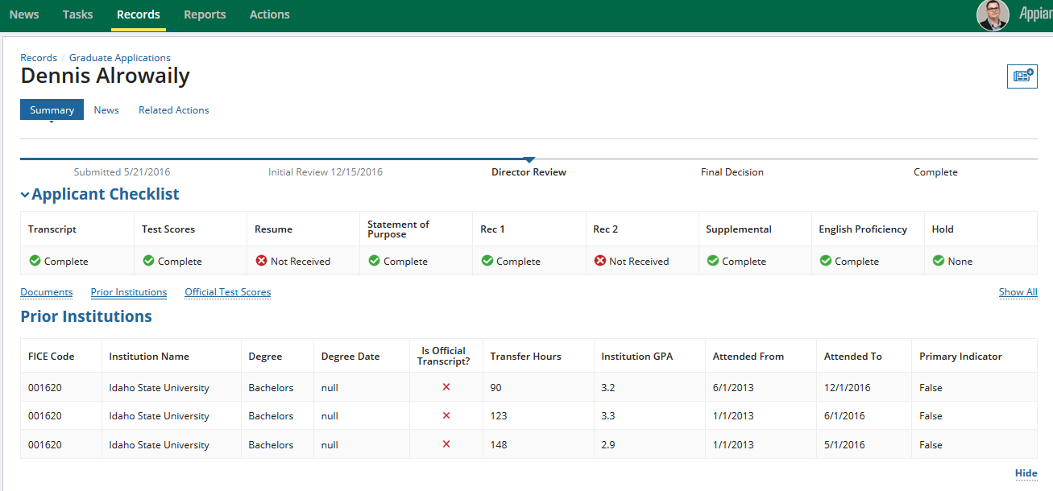

*Select “Hide” to conceal the “Prior Institutions” information*

*Select Prior Institutions to display details on an applicant’s Prior Institutions*

### Test Scores

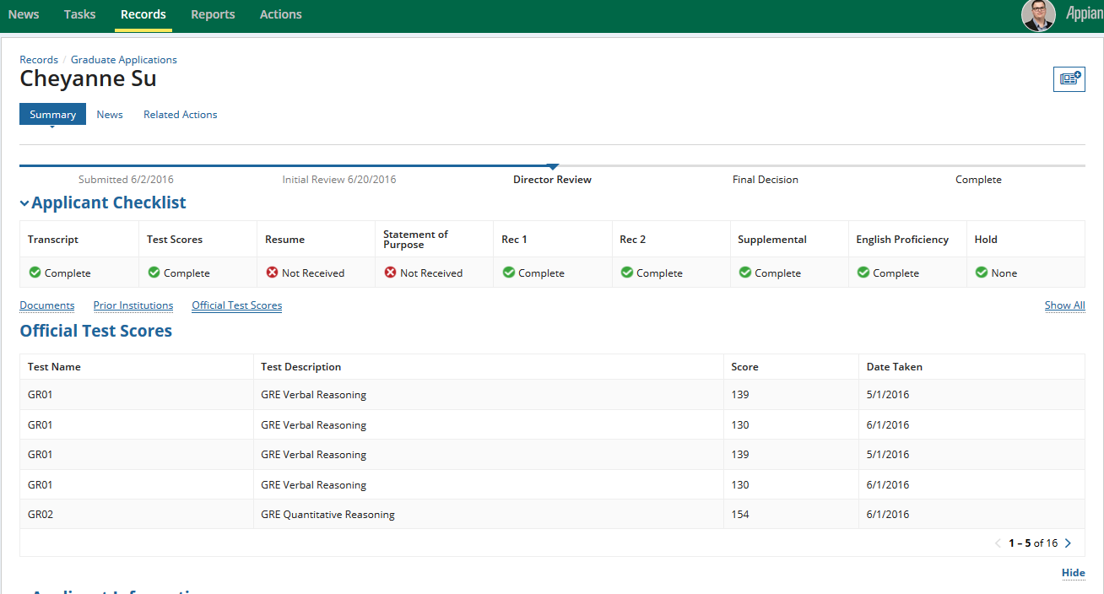

*Select “Hide” to conceal the “Test Score” information*

*Displays relevant test score information*

## Applicant Information

The Applicant information section provides a summary of the applicant’s biographical information, and includes the applicant’s name, address and information related to the program.

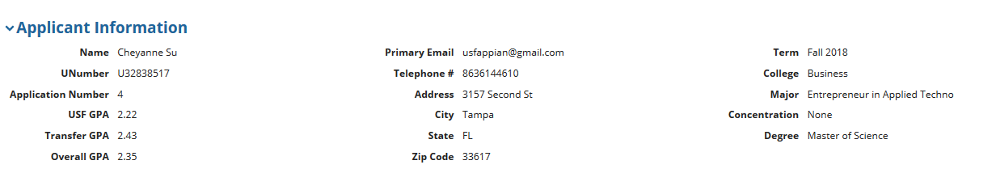

Figure 21. Displaying the Applicant Section

## Reviews

The “Reviews” section outlines the ratings alotted to an applicant by a reviewer. Each rating is followed by a timestamp, and a comment, if one has been provided by the reviewer. The Review section also outlines the average rating alloted to the candidate, and an overview of the number of participating faculty reviewers.

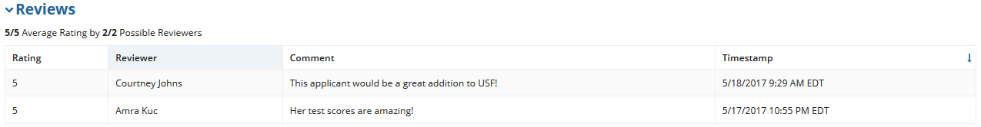

Figure 23. Displaying the Reviews section of the applicant record.

## History

The history presents an outline of the various actions taken on an application. Each action is noted by a timestamp, the name of the initiator and any comments that the user may have left.

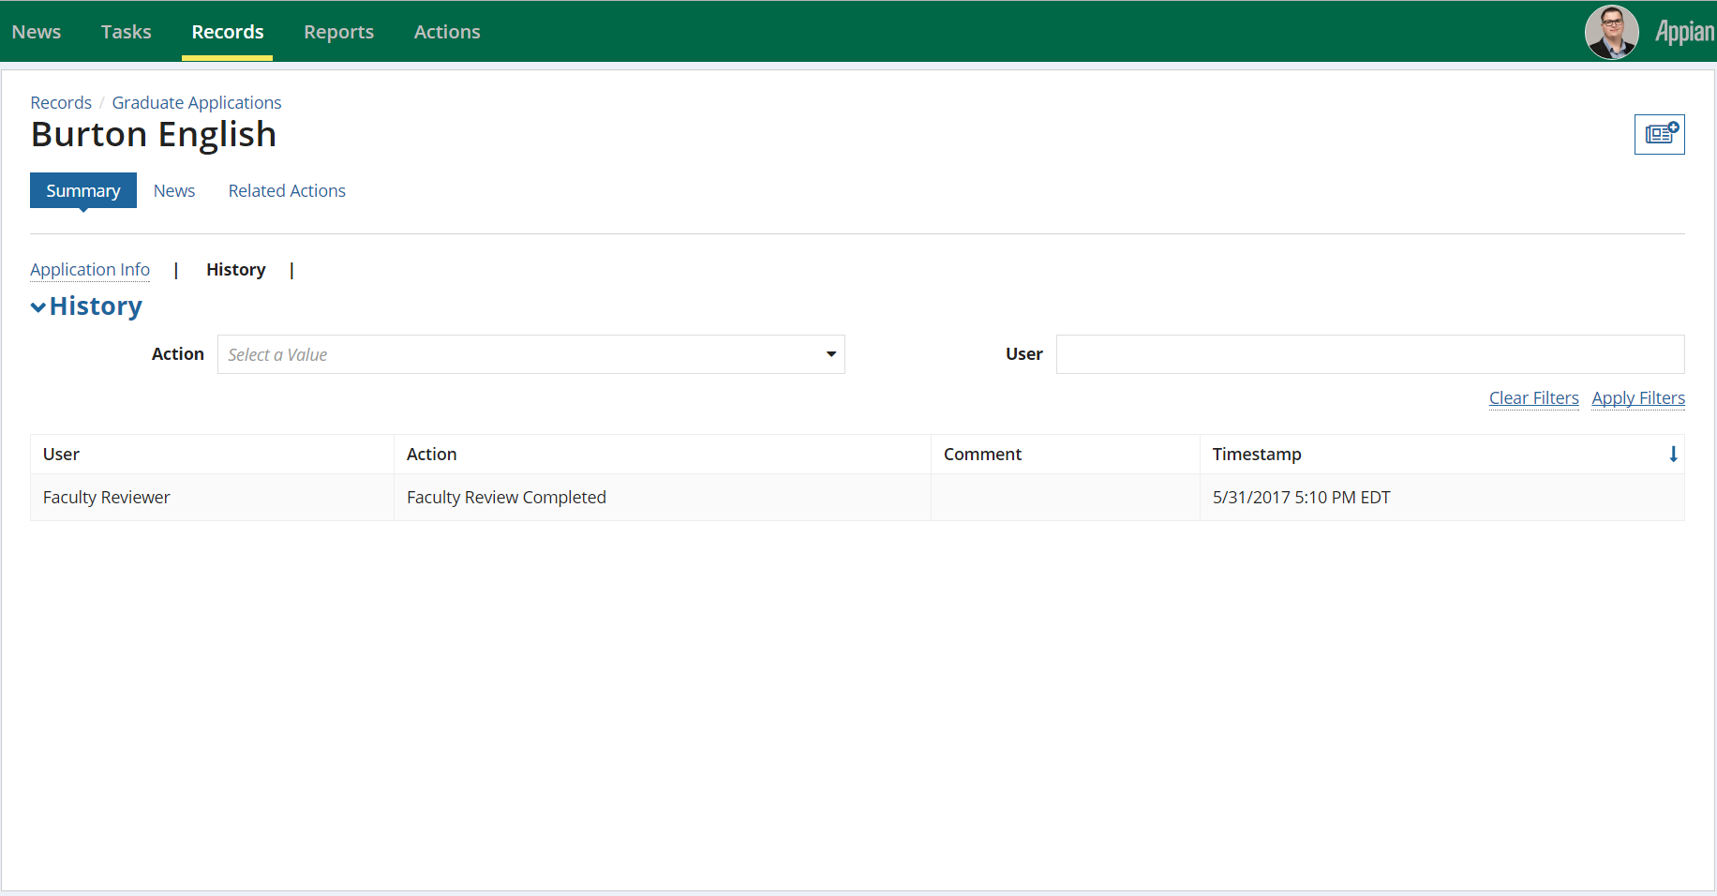

Figure 24. Display of the History Section of the Applicant record.

## Related Actions

A related action can be acessed by selecting the “Related Actions” tab, located above the milestone bar.

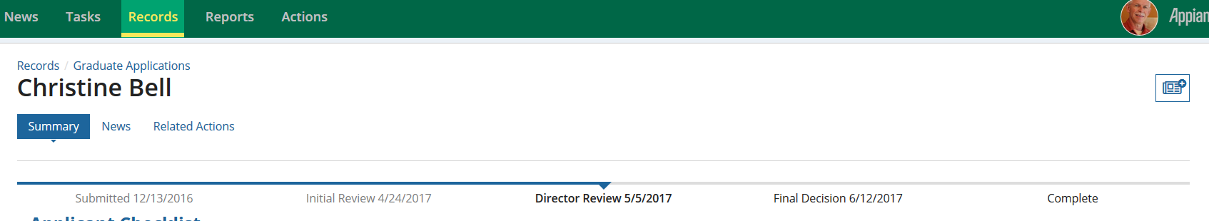

Figure 25. Displaying the interface of the related actions when access from the above the milestone bar.

### Add Note

Allow users at add a note, detailing any additional information that may be related to an applicant. Once the “Add Note” action is selected the user is able to view notes submitted by other faculty members, or add their own to the application. An audit of the submitted notes can also be located in the History section of the applicant’s record.

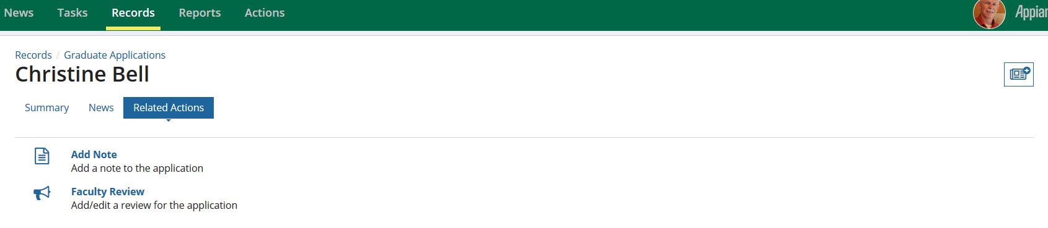

Figure 26. Displaying the "Add Note" related action.

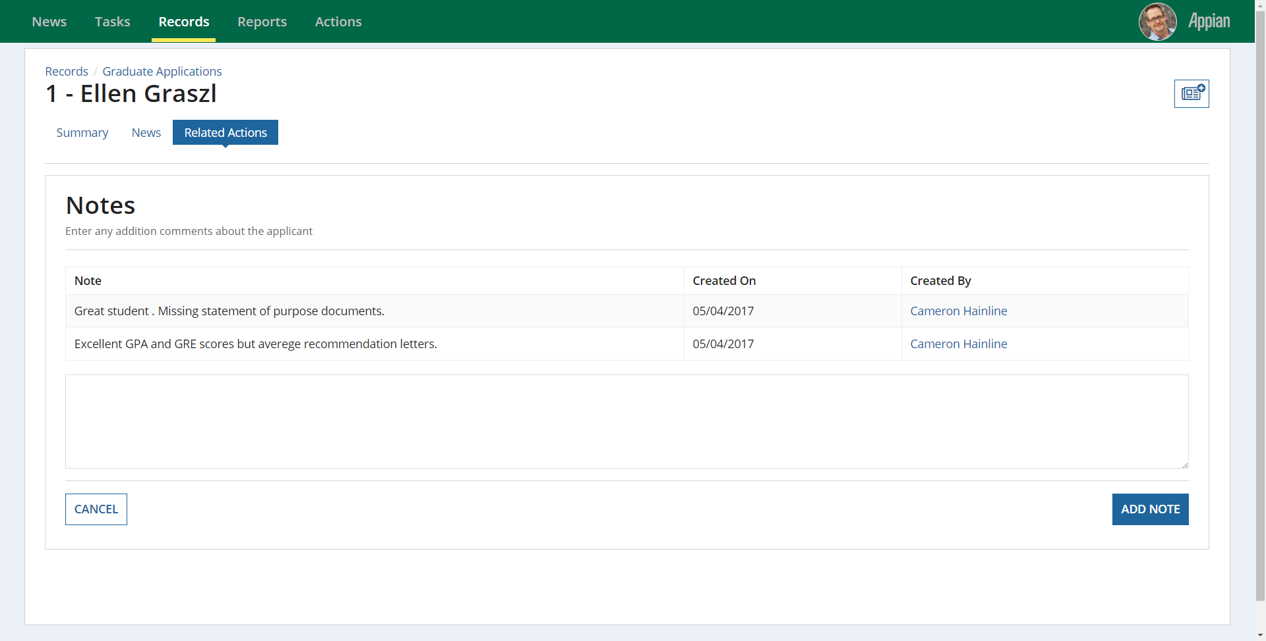

*History of previously submitted notes*

Figure27. Displaying the interface to add a note for the applicant

### Faculty Review

The Faculty Review related action allows Faculty Reviewers to add a review using the related action. Once the specific applicant is selected from the Graduate Admissions record, the reviewer is able to enter their rating using the prefered rating scale determined by the Department Designee.



Figure 30. Displaying the "Faculty Review" action.



Figure 31. Displaying the interface for the "Create Review" action.

### Update Application

The Update Application related action allows Graduate Admission Coordinators the exclusive permission to verify an applicant’s English Proficiency, Transcript, and Conduct status, while the Department Designees can verify the recommendations, Personal Statement, test scores and supplemental documents for an applicant.

The respective documents are marked as Completed by selecting the checkbox for the corresponding required documents, and the checklist in the “Applicant Checklist” (Figure 19) is adjusted accordingly. However, it should be noted that the changes to the checklist are only saved once the “Update” button is selected.

|  |  |
| --- | --- |
| **User** | **Permissions** |
| *Graduate Admission Coordinators* | * English Proficiency * Transcript * Hold |
| *Department Designees* | * Transcript * Test Scores * Resume * Statement of Purpose * Recommendations * Supplemental documents |

Table 1.Showing the checklist items accessible for Graduate Coordinator and Department Designees to verify via the Update Checklist related actions.

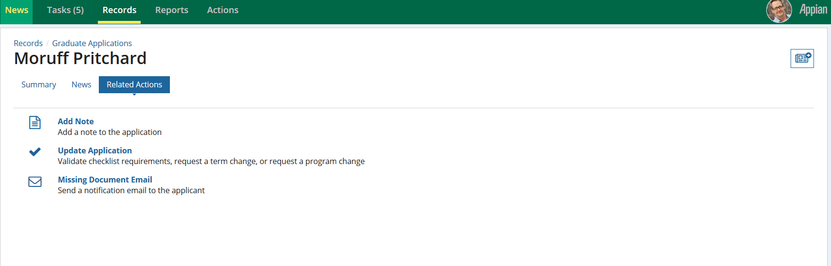

Figure 28. Displaying the "Update Application" related action.

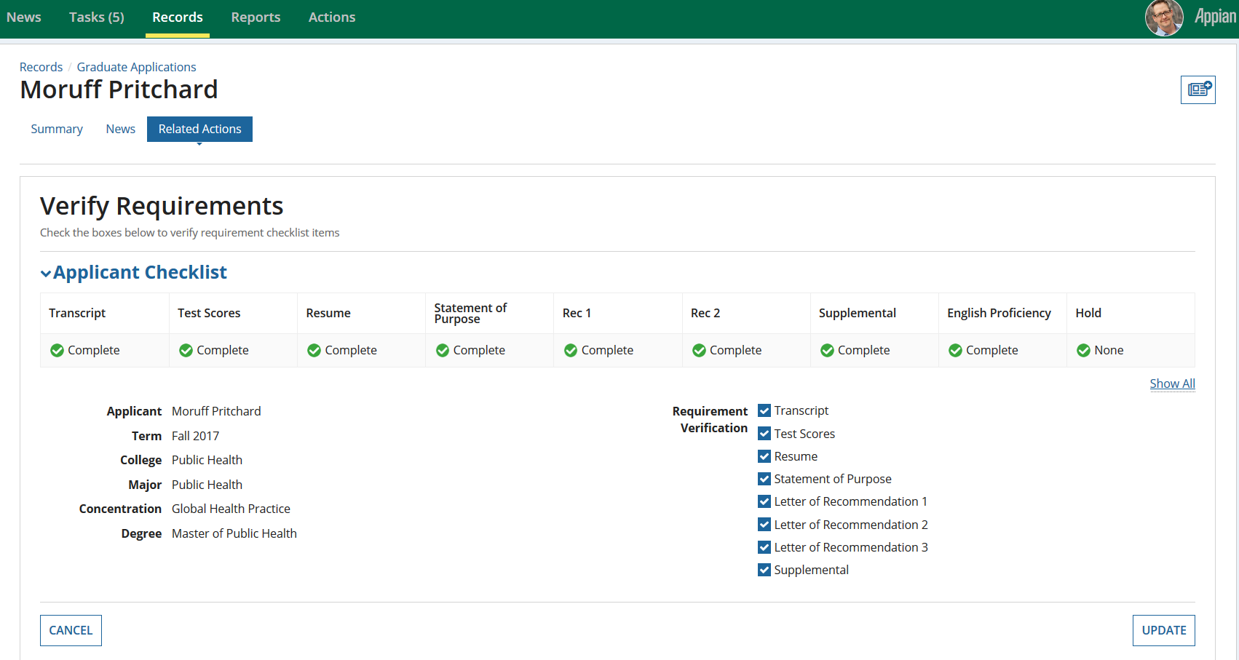Figure 29. Displaying the interface for the "Update Application" related action.

*Checking on each box will verify an applicant’s checklist*

### Exposing Review Results

To prevent bias among Faculty Reviewers, Appian has been designed to hide the ratings results submitted by a faculty reviewer until all reviewers designated to a specific program have submitted their results. Until then, Faculty Reviewers are only able to view the number of reviews that have been submitted for an application.

Program Directors are given the exclusive privilege to expose the review results for an application. Once exposed, Faculty Reviewers associated with that application will be able to view the average ratings, as well as the individual ratings submitted by specific Faculty Reviewers in the Review section of the applicant’s record.

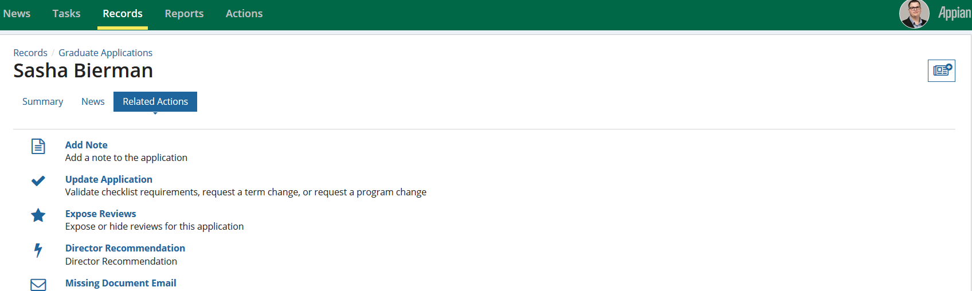

Figure 30. Displaying the "Expose Reviews" related actions.

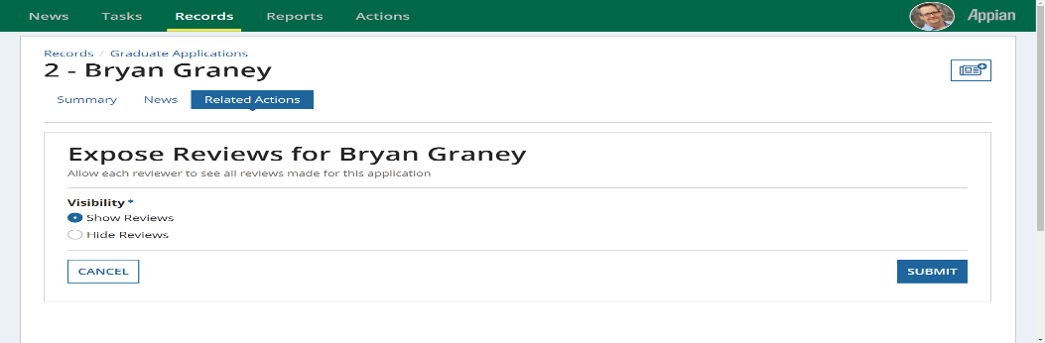

Figure 31. Displaying the interface for the "Expose Reviews" related action.

### Director Recommendation

Graduate Program Directors are able to submit a recommendation for an applicant using the “Director Recommendation” related action. This action allows Program Directors to admit, deny or waitlist an applicant based on the submitted faculty reviews and comments. In addition to applying a decision for an applicant, the Director Recommendation action also allows for the Director to leave an optional comment or expose the reviews. Once marked as visible the reviews can be viewed in the Reviews Section of the applicant’s record, and dashboard.

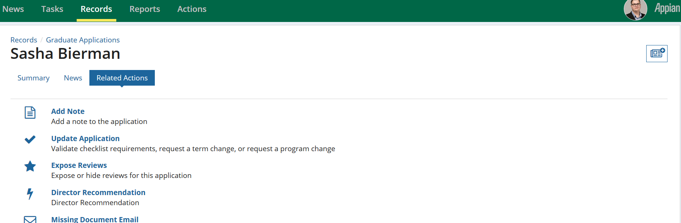

Figure 32. Displaying the "Director Recommendation" related action. 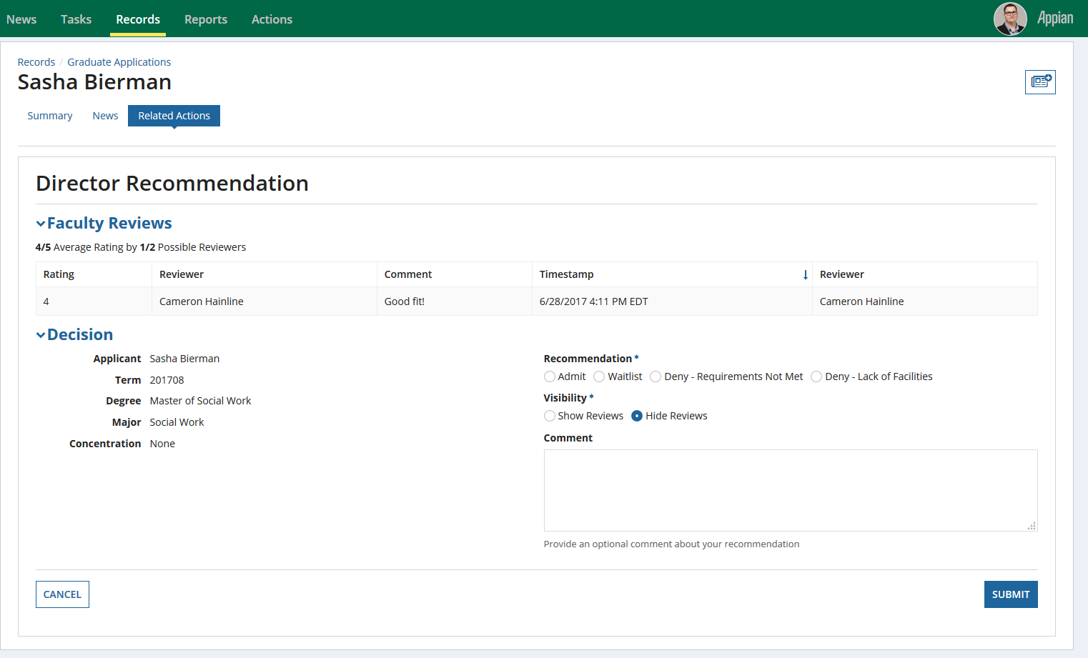

Figure 33. Displaying the interface for the "Director Recommendation"

### Updating the Applicant’s Term

Graduate Program Directors are able to request a term change for an applicant using the “Update Application” related action.

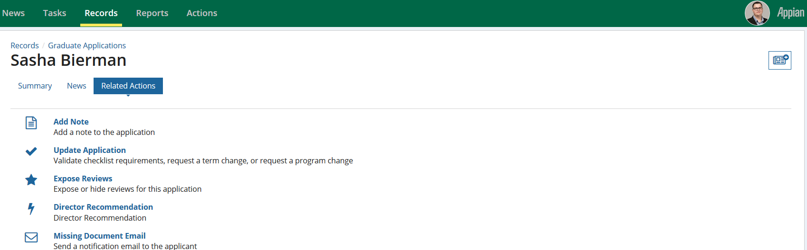

### Requesting a change in the Applicant’s Term

Graduate Program Directors are able to request a term change by selecting the Update Application from the Related Actions tab.

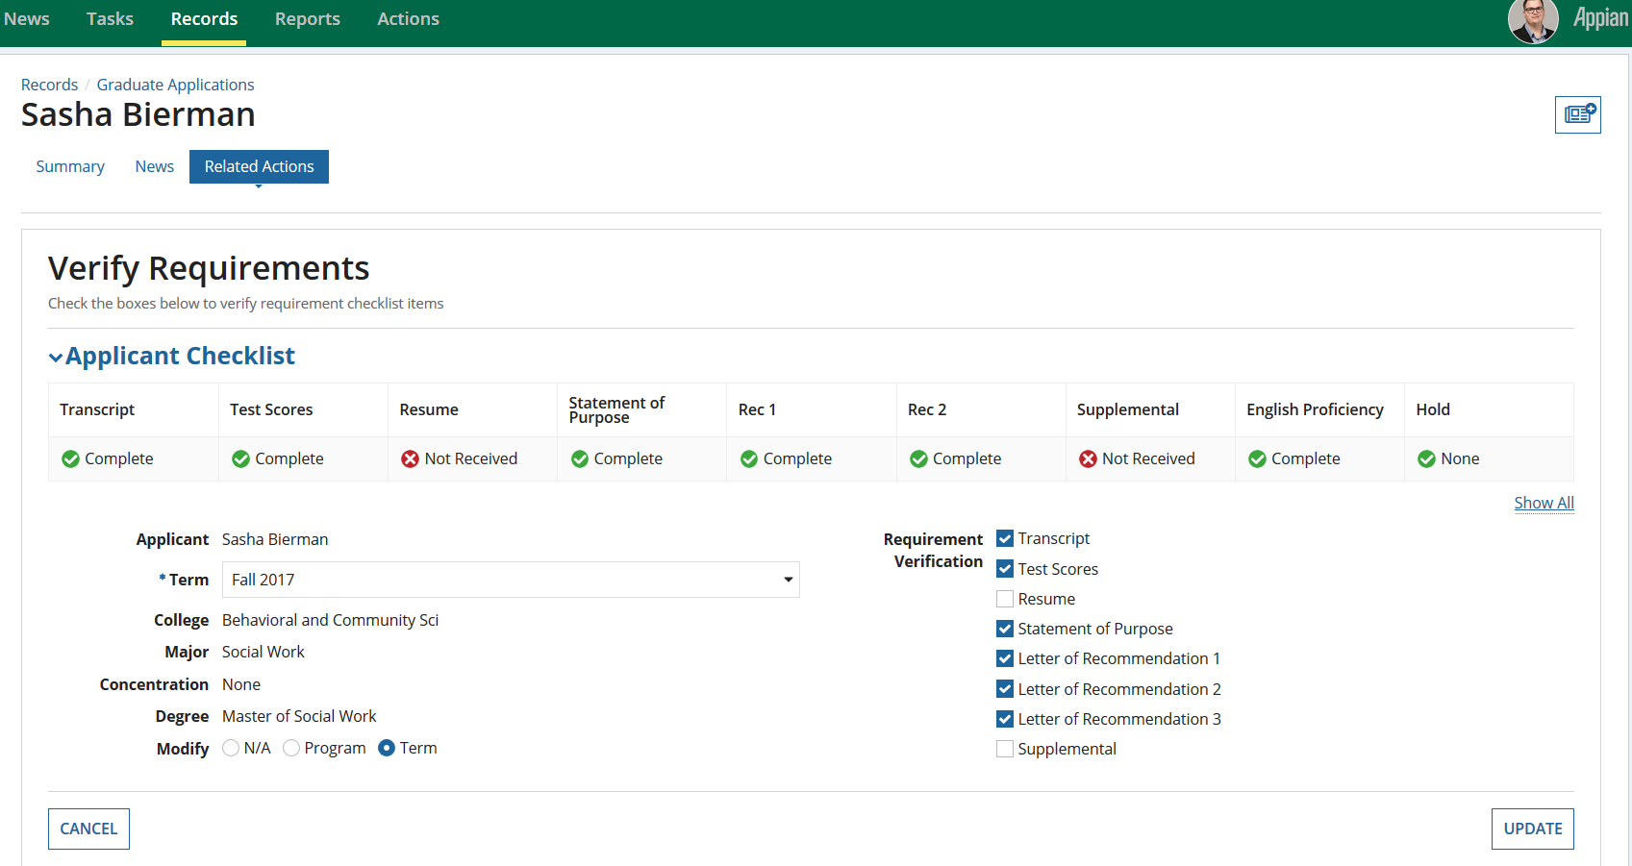

*Click on the Update button after the change to term is done*

*Select this Radio Button to modify the Term*

*Choose the Term to be changed*

### Approving changes for the Applicant’s Term

Once the Program director creates a request for an applicant’s Change of Term, this creates a new task for Graduate Admission Coordinators to approve or deny the change request. This task is available for Graduate Admission Coordinators either in the Tempo view or in the Graduate Admission Coordinator dashboard under My Tasks.

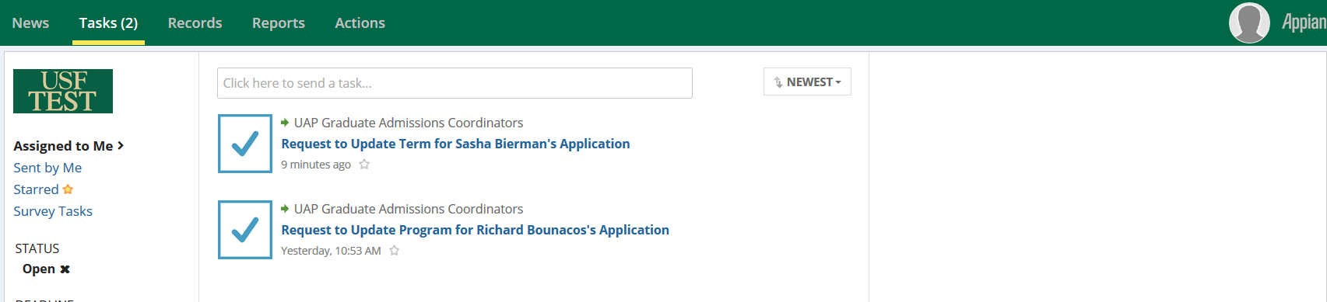

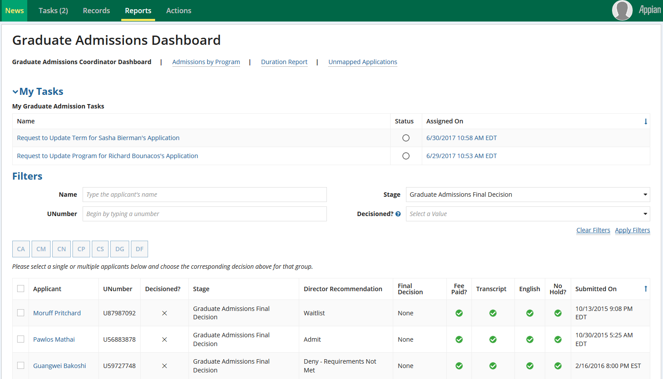

*Accept the task before proceeding to provide a response.*

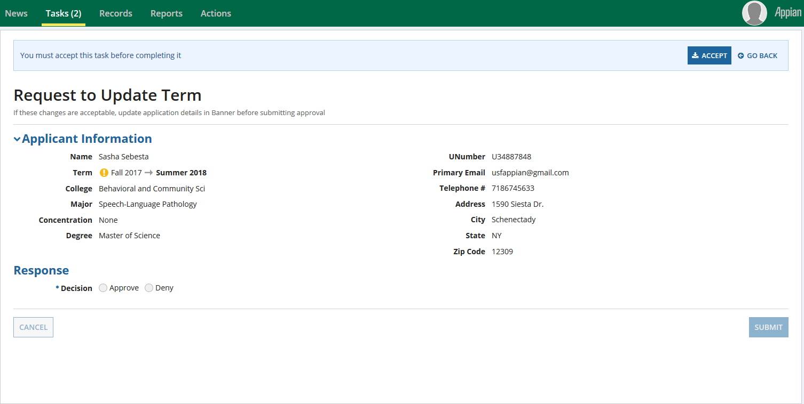

Figure 34. Displaying the interface for the Accepting the task to Approve/Deny the change of term request

As noted in the task, if the GAC is approving the change of term, the application details need to be updated in Banner before submitting approval. The GAC will need to provide the new application number before submitting approval. Once the Change of term is approved/denied by the Graduate Admission Coordinator, an email is sent to the Program Director about the status of the application. If the GAC approves the change of term, a copy of the application is created. 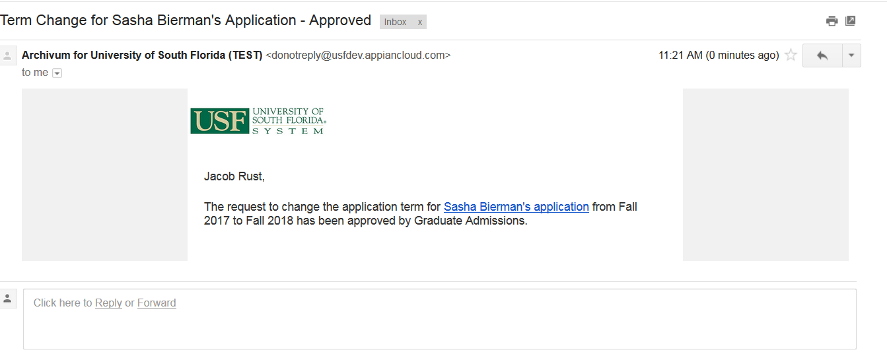

Figure 35. Displaying the Email sent to Director after the term change for an applicant is approved by Graduate Admission Coordinator.

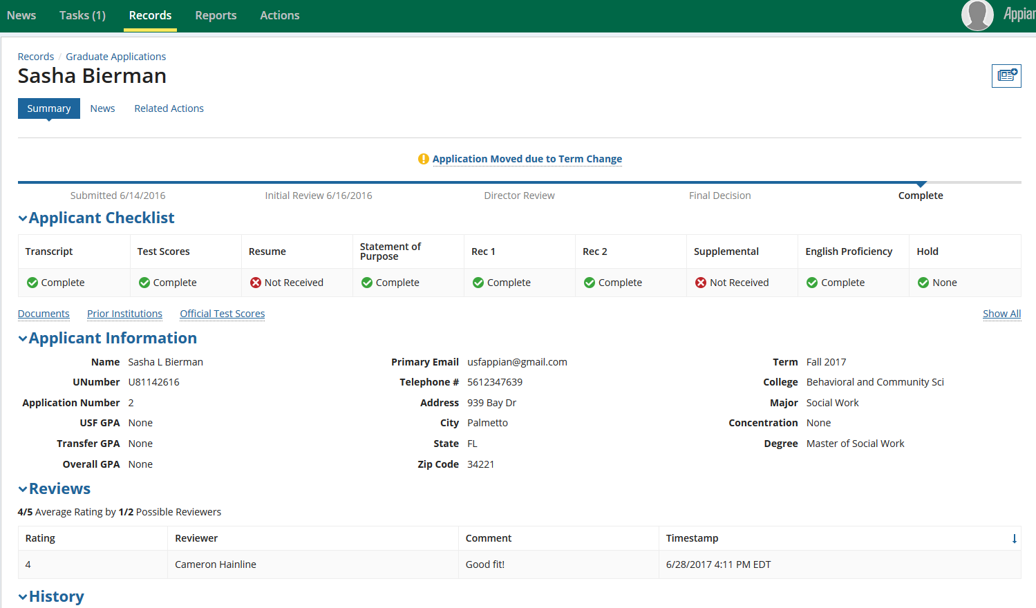

*The modified term can be viewed in the new application by clicking on this link.*

### Updating the Applicant’s Program

Graduate Program Directors are able to request a Program change for an applicant using the “Update Application” related action.



### Requesting a change in the Applicant’s Program

Graduate Program Directors are able to request a program change by selecting the Update Application from the Related Actions tab. They can change the concentration and degree.

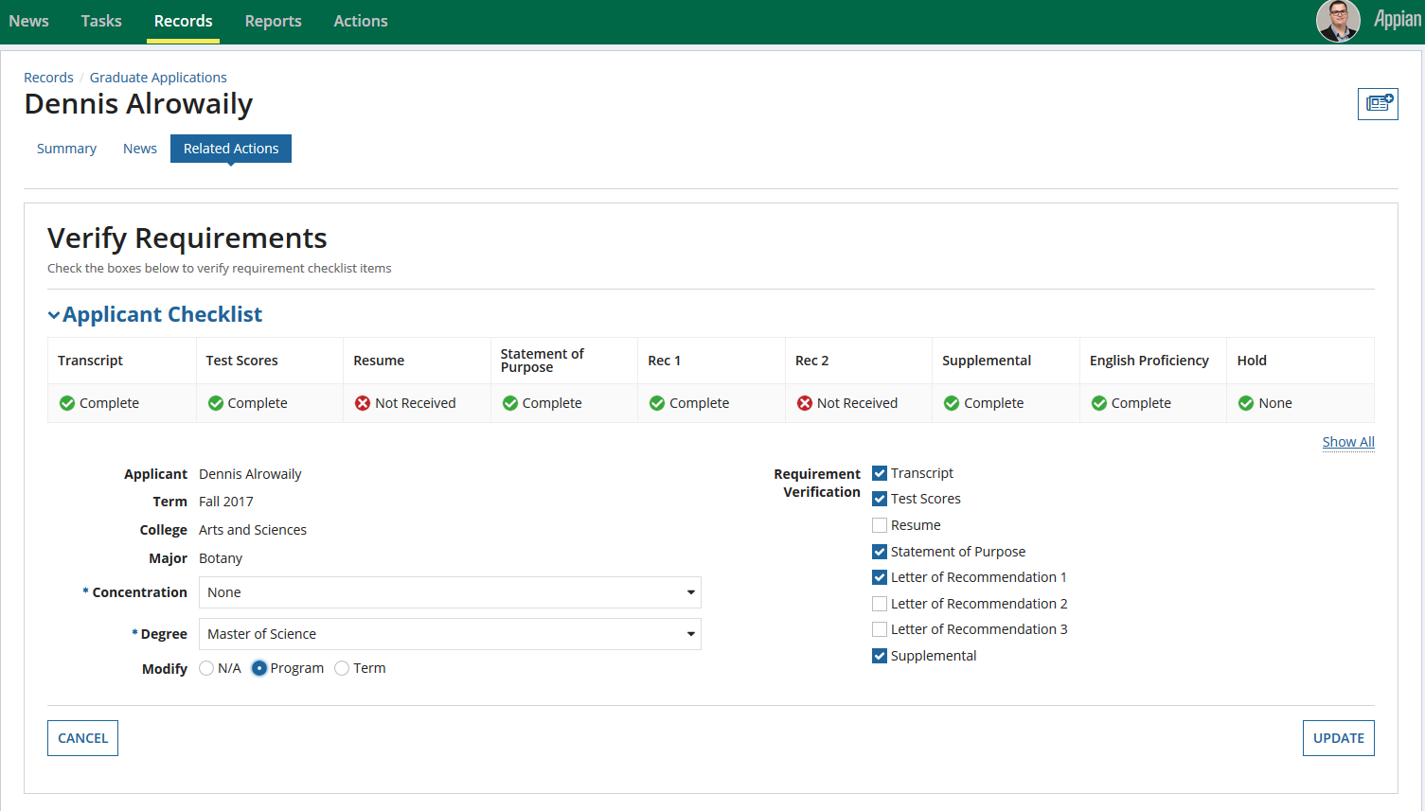

*Click on the Update button after the change to program is done*

*Select this Radio Button to modify the Program*

*Modify here to change the concentration and degree*

### Approving changes for the Applicant’s Program

Once the Program Director creates a request for an applicant’s Change of Program, this creates a new task for Graduate Admission Coordinators to approve or deny the change request. This task is available for Graduate Admission Coordinators either in the Tempo view or in the Graduate Admission Coordinator dashboard under My Tasks.

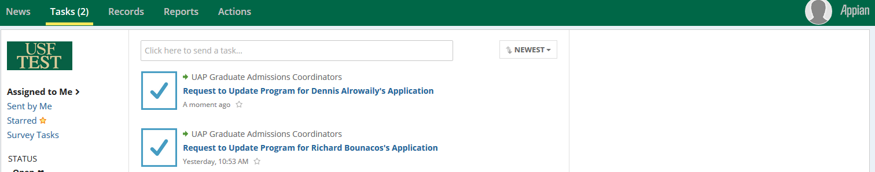

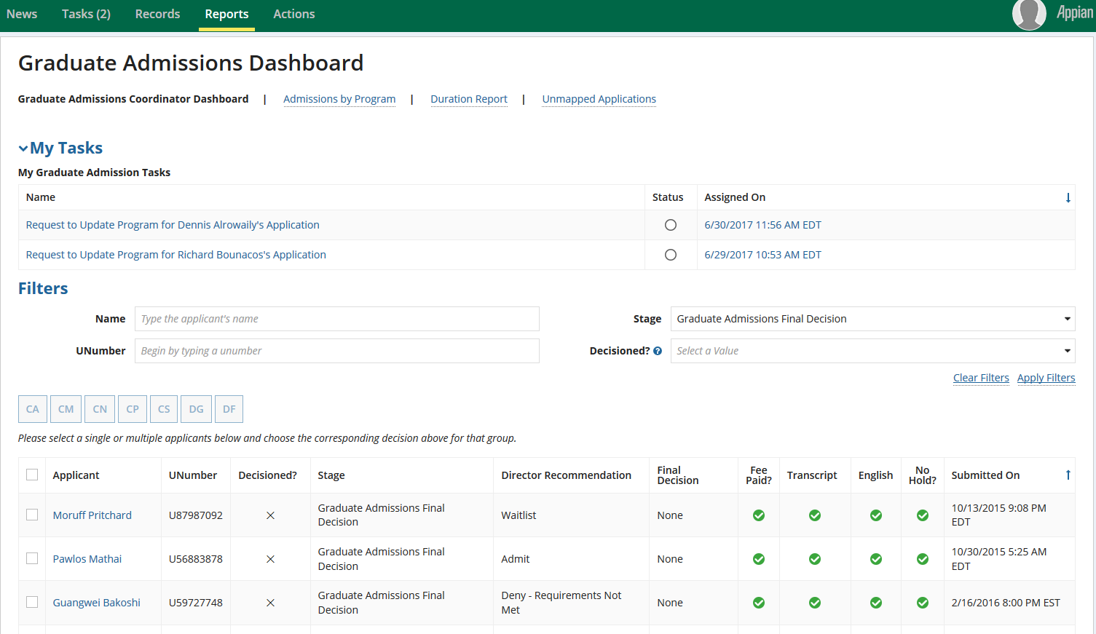

*Accept the task before proceeding to provide a response.*

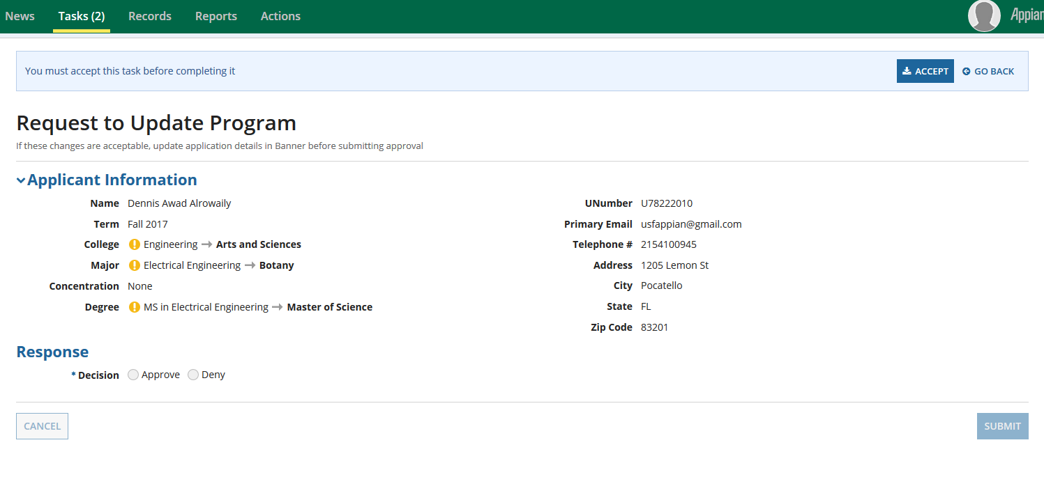

Figure 36. Displaying the interface for the Accepting the task to Approve/Deny the change of program request

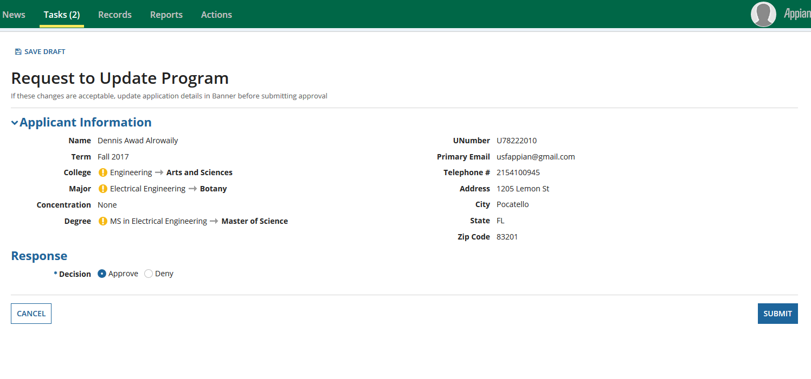

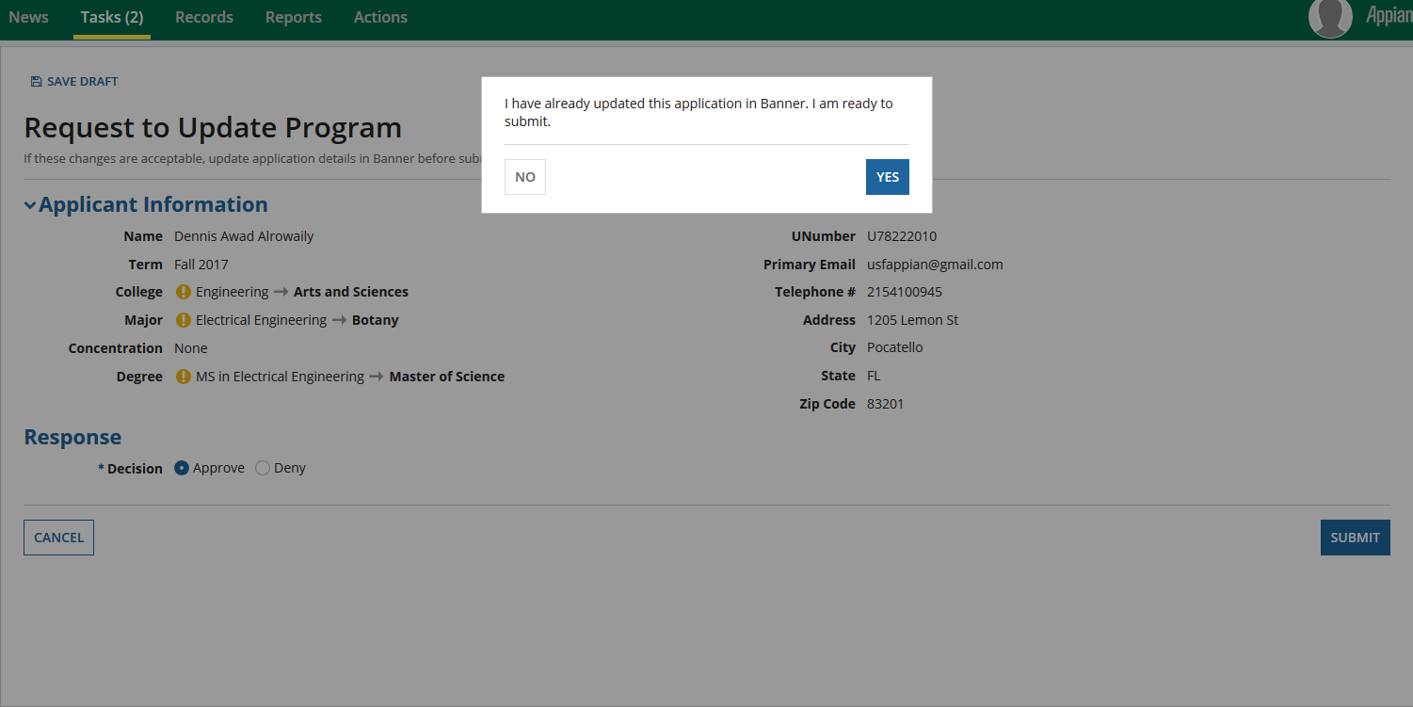

Figure 37. Displaying the confirmation message to update the application in Banner before approving the request

Once the Change of program is approved/denied by the Graduate Admission Coordinator, an email is sent to the Program Director about the status of the Application. If the GAC approves the change of program, the changes are reflected in the applicant’s record.

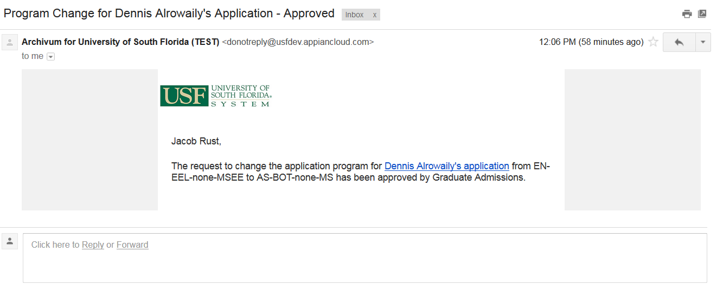

Figure 38. Displaying the Email sent to Director after the term change for an applicant is approved by Graduate Admission Coordinator.

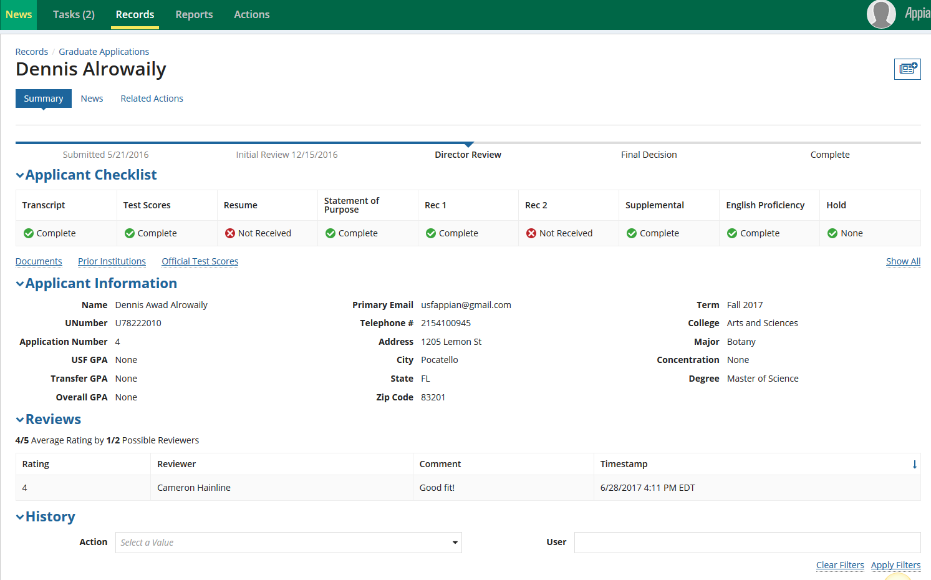

*The modified term and college details can be seen in applicant information*